**Maven**

**Section 1: Maven Basics**

1. **Introduction:**
2. **What is Maven?**

**Maven**is a build automation tool developed using the Java programming language. It is primarily used for Java-based projects to manage the build process, including source code compilation, testing, packaging, and more. Maven utilizes the Project Object Model (POM), where the pom.xml file describes the project’s configuration and dependency management.

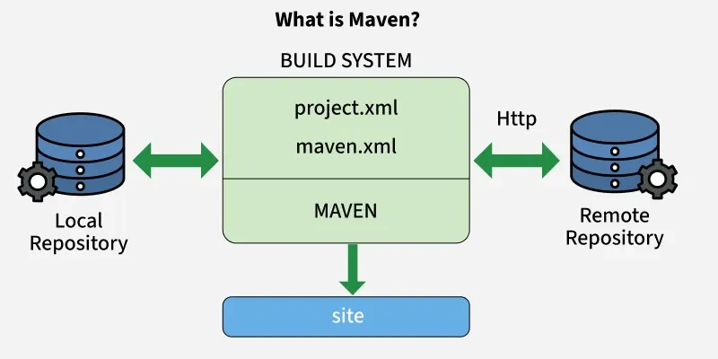

1. **Features of Maven:**

* **Dependency Management:** Automatically downloads and manages external libraries.
* **Standard Project Structure:** Follows a fixed folder layout for source, test, and other files.
* **Build Lifecycle:** Defines standard build phases like compile, test, and deploy.
* **Plugins:** Supports plugins for compiling, testing, packaging, and more.
* **POM File:** Uses pom.xml to manage configuration and dependencies.
* **Central Repository:** Fetches dependencies from a shared online repository.
* **Build Profiles:** Supports different settings for dev, QA, and production.
* **Reporting:** Can generate Javadoc, test reports, and project documentation.
* **IDE Support:** Integrates with Eclipse, IntelliJ, NetBeans, etc.

1. **Maven Project Structure:**

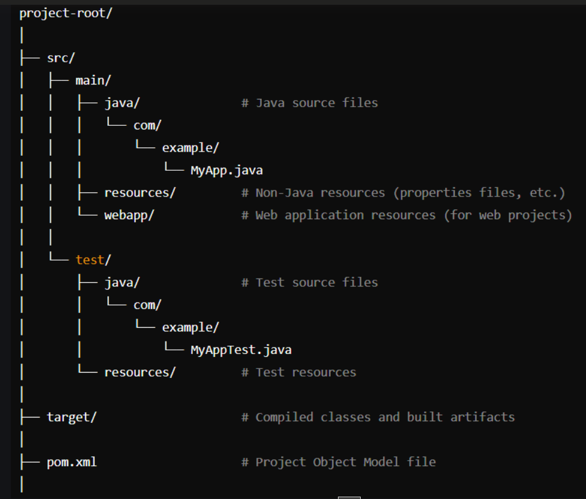

* src/main/java: It contains the main Java source code.
* src/main/resources: It contains non-Java resources used by the application.
* src/main/webapp: It contains resources for web applications.
* src/test/java: It contains test source code.
* src/test/resources: It contains resources used for testing.
* target: It contains compiled classes, packaged JARs/WARs, and other built artifacts.
* pom.xml: The Project Object Model file that defines the project configuration, dependencies, and build settings.

1. **Maven Build Life Cycle:**

In Maven Build life cycle there are different phases these phases are used for different purposes like test phase for complies tests, verify phases is used for tests and main source code and other.

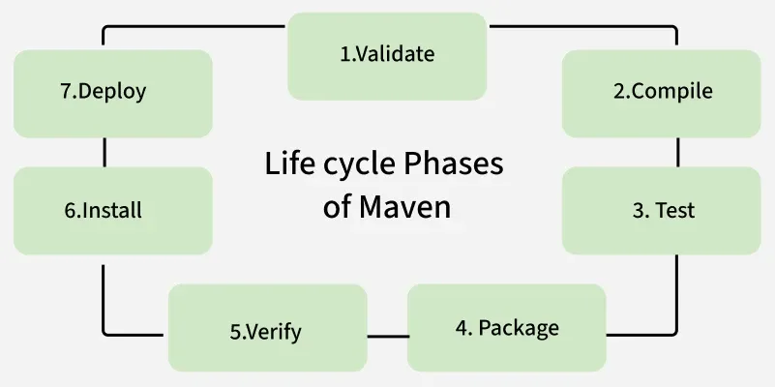

* **Validate:**This phase is responsible for validates if the project structure is correct or not.
* **Compile:**It compiles the source code, converts the .java files to .class, and stores these classes in the target/classes folder.
* **Test:**It runs unit tests for the maven project
* **Package:**This phase is responsible for distribute complied code in the format of WAR, JAR and others.
* **Integration test:**It runs the integration tests for the maven project
* **Verify:**verify that the project is valid and meets the quality standards.
* **Install:**This phase is responsible for install packaged code on the system.
* **Deploy:**copies the packaged code to the remote repository for deployment then other developers can easily access this one.

1. **Advantages of Maven Build Tool:**

This tool provides a lot of advantages and most of the Software team use this tool for Automation Building.

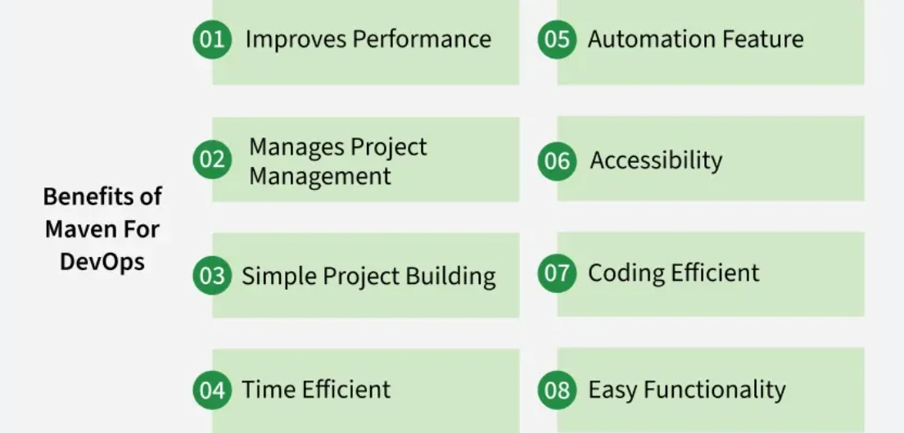

* **Dependency Management:**This Maven Tool can able to handle required Dependencies in the Software application. Maven simplifies dependency management by automatically downloading required libraries from repositories and managing their versions
* **Consistent Project Structure:**It Provides a standard project structure to understand easily by the developers.
* **Build Life cycle:**The Maven tool provides lot of Build Phase like verify, test and other build phases and Binds the phases with plugins.
* **Re usability:**Maven promotes the reuse of project components through the use of dependencies and plugins, reducing duplication of effort.
* **Integration with IDEs:**It supports IDEs like STS, Eclipse, IntelliJ IDEA, and NetBeans.
* **Automated Testing:** The Maven provide testing commends for testing the test source code while go with test build phase in the Maven type project.

===================================================================================

1. **Introduction to Apache Maven:**

Maven is a powerful project management and comprehension tool primarily used for Java projects, especially large and complex ones. Its core function is to streamline the processes of building, packaging, testing, and deploying applications by utilizing a standardized project structure and predefined lifecycles. Developers manage project configurations, external libraries, and build logic using the central Project Object Model (POM) file, making the development process more consistent and efficient.

**Key Terminologies:**

Project Object Model (POM) Files: These are central XML configuration files (pom.xml) that hold all project-related information, including dependencies, plugins, goals, and source directories. Maven reads this file to execute commands and manage the project build.

Dependencies and Repositories: Dependencies are the external Java libraries (JAR files) a project needs. Repositories are directories where these packaged files are stored. The local repository is on your machine, and if a dependency is missing there, Maven automatically downloads it from a central repository.

Build Life Cycles, Phases, and Goals: The build process is structured by a lifecycle (a complete process), which consists of ordered phases (stages like compile, test, package), and each phase is executed by a sequence of goals (specific tasks). Executing a lifecycle executes all its phases; executing a phase executes all preceding phases.

Build Profiles: These are sets of configurable values used to build the project under different environmental conditions (e.g., local development, testing, or production). Profiles are defined in the pom.xml and allow developers to switch between configurations easily.

Build Plugins: These are components used to perform specific actions or goals during the build process. Maven comes with standard plugins, but developers can also implement custom ones and configure them within the pom.xml file.

**Maven Architecture:**

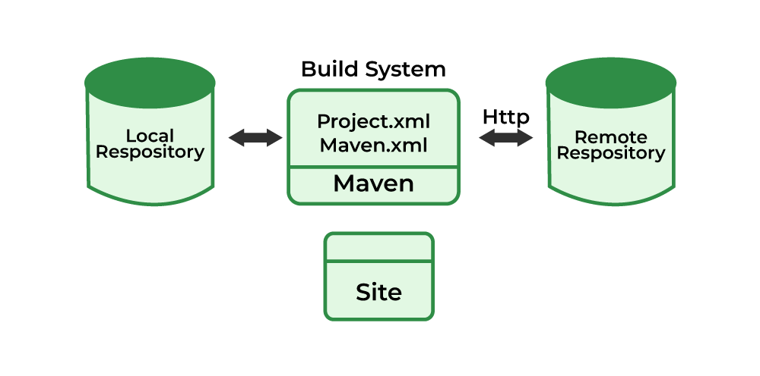

**Maven is built around two key components: POM (Project Object Model) and repositories.**

**1. Project Object Model (POM)**

**The pom.xml is the main component of any Maven project. It defines:**

* **Project metadata: groupId, artifactId, version**
* **Dependencies: External libraries needed**
* **Build setup: Plugins and lifecycle phases**
* **Project info: Developers, license, source control**

**2. Maven Repositories:**

A **Maven repository** is essentially a structured directory that stores **packaged JAR files** (the compiled code for libraries and projects) along with their **metadata**. The metadata is contained in **Project Object Model (POM) files**, which are XML files that define the project's configuration, including its external **dependencies** (other libraries the project needs to compile or run).

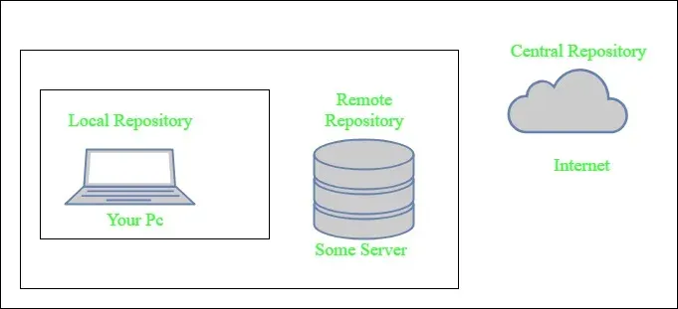

Maven's core function is to automatically **fetch and store** these dependencies. It does this by checking three distinct types of repositories in a specific order:

**1. Local Repository 🏠**

* **Location:** A directory on the developer's machine, typically at user_home/.m2 (e.g., C:\Users\asingh\.m2).
* What it is: This is a folder right on your computer.
* **Purpose:** It acts as a **cache** for all dependencies that Maven downloads.
* **Benefit:** Maven only needs to **download** a dependency **once** from an external source. If multiple projects require the same dependency (like an ODBC driver), they all use the version already stored in the local repository, saving time and bandwidth.
* Analogy: Think of it as your backpack or personal shelf at home.
* How it works: When the librarian (Maven) gets a new book, he first puts a copy in your backpack. Once a book is in your backpack, you never have to go to the big library to get it again! You only need to reach into your backpack. This saves a lot of trips.
* **Example:** If your computer already has the **JUnit** testing tool downloaded in the folder C:\Users\asingh\.m2, Maven will use that copy instead of downloading it again.

**2. Central Repository 🌐**

* **Location:** Maintained by the Maven community (e.g., repo.maven.apache.org).
* What it is: This is a huge library on the internet, shared by everyone who uses Maven.
* **Purpose:** It is the **primary public source** for most common, stable, and open-source libraries (e.g., JUnit).
* **Mechanism:** If a dependency is **not found** in the local repository, Maven automatically checks the central repository and, upon finding it, downloads it to the **local repository**.
* Analogy: This is the main, public city library. It has almost every common, popular book you could ever need.
* How it works: If a book is not in your backpack (Local Repository), Maven goes straight to the Central Library. If they find the book there, Maven downloads it and copies it into your backpack for next time.
* Example: Maven needs the Log4j library (a popular tool for writing messages) and hasn't seen it before. It goes to the main website, repo.maven.apache.org, downloads it, and puts it in your local .m2 folder.

**3. Remote Repository 📡**

* **Location:** A repository hosted on a web server, often managed internally by an organization (e.g., an internal Nexus server at <http://nexus.company.com/repository/maven-releases>).
* **What it is:** This is another library on the internet, often set up by a specific company or organization.
* **Purpose:** Primarily used for hosting **company-specific** or proprietary libraries, or for using a mirror of the central repository.
* **Mechanism:** If a dependency is **not found** in either the local or central repository, Maven can be configured to check one or more remote repositories and then downloads the dependency to the **local repository**.
* Analogy: This is like your school's special library collection or a private library. It holds special books that only your school (company) uses and that aren't available at the public city library.
* How it works: If a book is not in your backpack AND not at the Central Library, Maven can be told to check this special Remote Library. If the book is found, Maven downloads it and puts it in your backpack.
* Example: Your company wrote its own secret library called CompanyBilling-v3. This library is stored on the company's internal server, like http://nexus.company.com/, and Maven needs to connect there to get it.

**Use Cases of Maven:**

Maven is a popular build automation and project management tool, especially for Java-based projects.

* **Java Project Builds**: Maven automates Java project builds, including tasks like compilation, testing, packaging (JAR, WAR), and deployment.
* **Dependency Management**: Maven simplifies dependency management by automatically downloading and including required libraries from central repositories, handling transitive dependencies.
* **Continuous Integration and Delivery (CI/CD)**: Maven integrates with CI/CD tools like Jenkins, GitLab CI, and Travis CI, automating build, test, and deployment phases for rapid, consistent software delivery.
* **Automated Testing**: Maven works seamlessly with testing frameworks (e.g., JUnit, TestNG) to automate unit, integration, and other types of tests during the build process.
* **Project Standardization and Documentation**: Maven enforces a standardized project structure and generates comprehensive documentation, including dependency reports, test results, and code analysis.

===================================================================================

1. **Features Of Maven:**

Maven is a powerful project management and build automation tool developed by the Apache Software Foundation. Primarily used for Java projects (though it now supports other languages as well), its main goal is to simplify and standardize the build process. Maven achieves this by providing a complete build lifecycle with different phases, and it consistently manages key aspects of a project, including dependencies, documentation, and releases. In essence, it offers a uniform system for managing the project build and deployment.

**Maven Features:**

Maven provides a lot of features to make the build process easy while building the project. Below we provide those features with examples for your reference.

* **Project Management and Comprehension Tool:**
  + Consistency: Standardizes project structures and conventions.
  + Documentation: Automatically generates project documentation.
* **Dependency Management:**
  + Centralized Repository: Manages and downloads project dependencies from a central repository.
  + Transitive Dependencies: Automatically includes dependencies of dependencies.
* **Build Automation:**
  + Life cycle Management: Defines a set of build phases (e.g., compile, test, package).
  + Plugins: Extensible through a wide range of plugins for different build tasks.
* **Reproducible Builds:**
  + Project Object Model (POM): Uses a POM file to define project configurations, ensuring reproducible builds.
  + Profiles: Supports build profiles for different environments (e.g., development, testing, production).
* **Integration with Development Tools:**
  + IDE Integration: Supports integration with popular IDEs like Eclipse, IntelliJ IDEA, and NetBeans.
  + Continuous Integration: Easily integrates with CI tools like Jenkins, Bamboo, and Travis CI.
* **Version Control:** Versioning: Manages project versions and facilitates continuous delivery.

**Maven Directory Structure:**

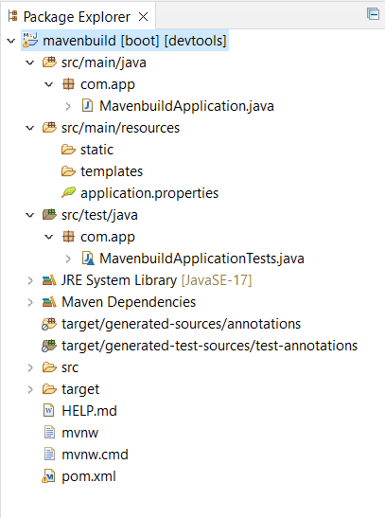

**pom.xml file:**

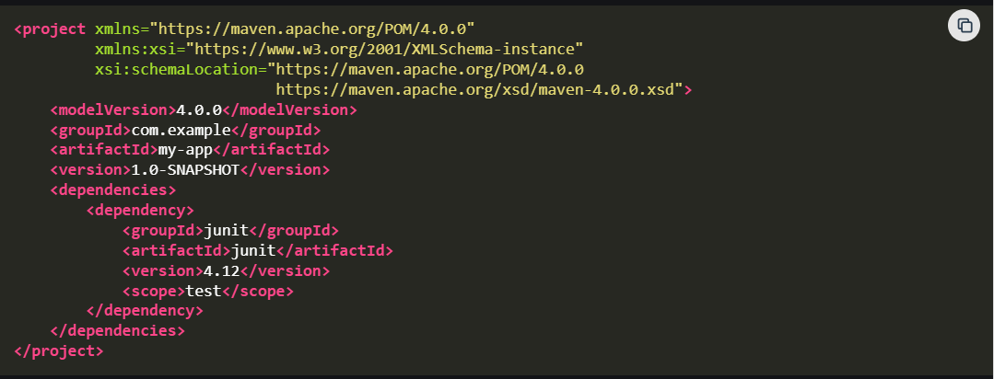

**Common Maven Commands:**

Maven provides various commands to manage the project life cycle. Some of the common commands include:

* **mvn clean**: It cleans the project by removing its target directory.
* **mvn compile**: It compiles the source code.
* **mvn test**: It runs the tests.
* **mvn package**: It packages the compiled code into a JAR file.
* **mvn install**: It installs the package into the local repository.

===================================================================================

1. **Maven Build Lifecycle:**

Maven Build Lifecycle is a fundamental concept in Maven that defines a sequence of phases and goals to be executed for managing the entire build process, from compilation to deployment.

There are three primary types of build lifecycles in Maven:

* **Default Lifecycle**: Handles the standard deployment process of the project, from compiling the code to packaging and installing it.
* **Clean Lifecycle**: Manages the cleaning process by removing artifacts from previous builds to ensure a fresh build environment.
* **Site Lifecycle**: Deals with generating and deploying the project's site documentation, such as project reports and other documentation.

Each lifecycle consists of several phases, and when you execute a phase, all preceding phases are also executed.

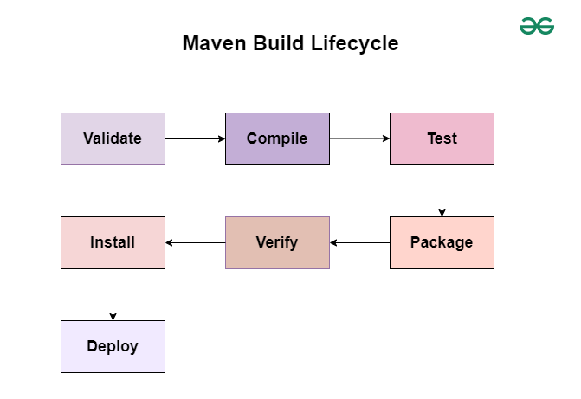

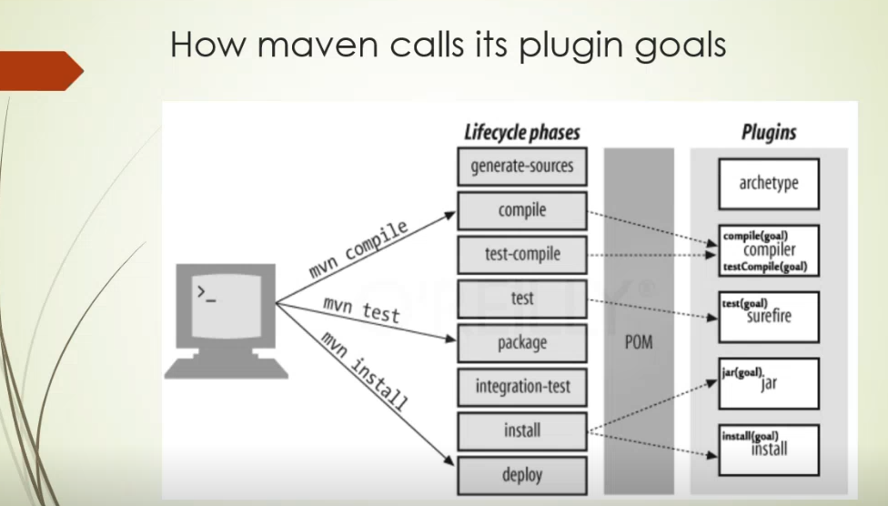

**1. Default Lifecycle**

The Default Lifecycle is the most commonly used lifecycle, focusing on the build process from validation to deployment.

Phases in this lifecycle are as follows:

1. **Validate Phase**: Checks the project configuration to ensure all necessary information is present and valid.
2. **Compile Phase**: Compiles the source code of the project.
3. **Test Phase**: Runs unit tests using a testing framework to ensure the code works as expected.
4. **Package Phase**: Packages the compiled code into a JAR, WAR, or other artifact format.
5. **Verify Phase**: Performs additional checks on the packaged code to ensure it is valid.
6. **Install Phase**: Installs the packaged artifact into the local repository for use as a dependency in other projects.
7. **Deploy Phase**: Deploys the packaged artifact to a remote repository for sharing with other developers or teams.

**2. Clean Lifecycle**

The Clean Lifecycle is designed for cleaning the project, ensuring that artifacts generated from previous builds are removed before starting the new build process.

Phases in the Clean Lifecycle:

1. **pre-clean**: Executes processes before cleaning.
2. **clean**: Removes files generated by the previous build.
3. **post-clean**: Executes processes after cleaning.

**3. Site Lifecycle**

The Site Lifecycle is responsible for generating and deploying project documentation.

Phases in the Site Lifecycle:

1. **pre-site**: Executes processes before generating site documentation.
2. **site**: Generates the site documentation.
3. **post-site**: Executes processes after generating site documentation.
4. **site-deploy**: Deploys the generated site documentation to a web server.

**Example Workflow Using Maven:**

Once the business logic is developed, navigate to your Maven project folder using the command prompt. Execute the following Maven commands to observe the expected output in the build lifecycle.

**Example 1: Default Lifecycle**

Here we created a sample Maven project using the Spring Tool Suite IDE with the required project dependencies. Below we provide those dependencies for your reference. Once the project is created successfully. After this, the build process is started.

1. This command checks if the project is correct and all necessary information is available.

mvn validate

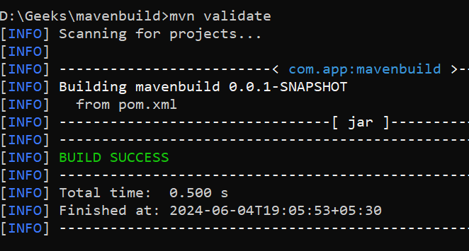

2. This command compiles the source code of the project.

mvn compile

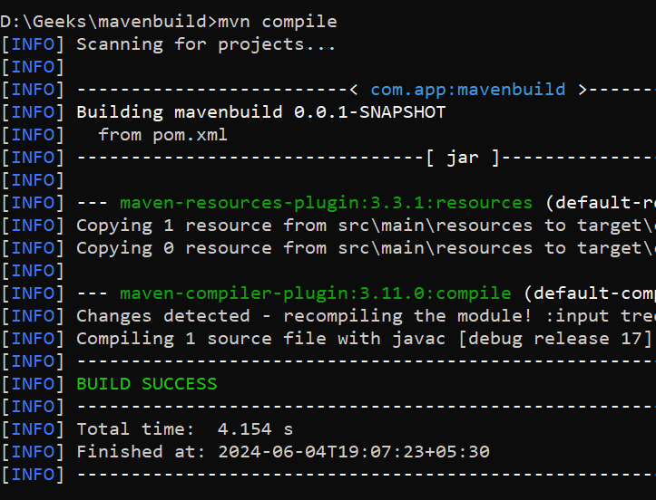 Maven Build Success: 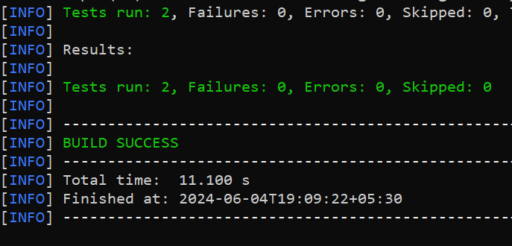

3. This command runs the unit tests for the project.

mvn test

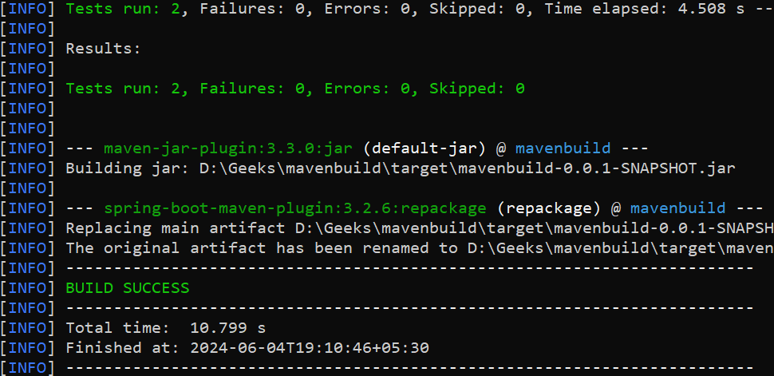

4. This command packages the compiled code into a JAR or WAR file.

mvn package

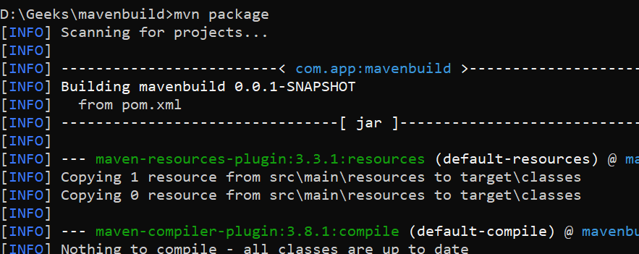

5. This command runs any checks to verify the quality of the package.

mvn verify

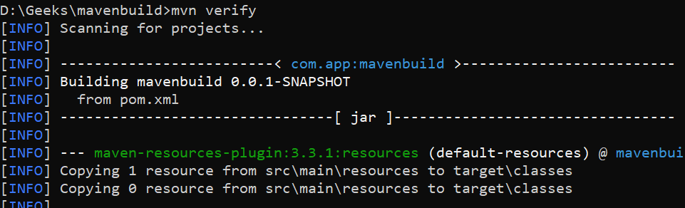

6. This command installs the package into the local repository for use as a dependency in other projects locally.

mvn install

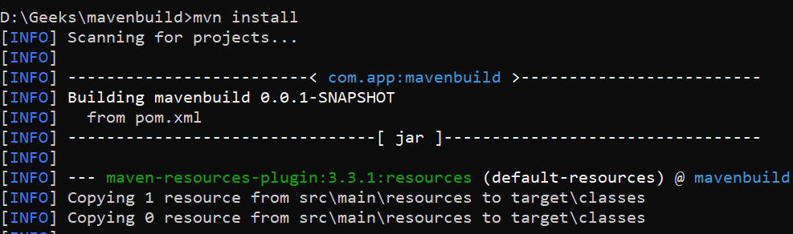 Build Successfully: 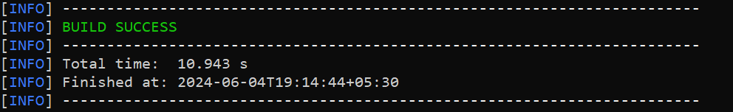

7. This command deploys the package to a remote repository for sharing with other developers.

mvn deploy

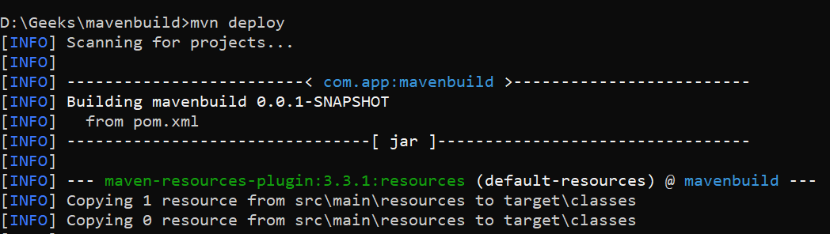

**Example 2: Clean Lifecycle**

In this example, we explain the Clean Lifecycle phases. Follow the steps below:

1. Executes processes needed before cleaning:

**mvn pre-clean**

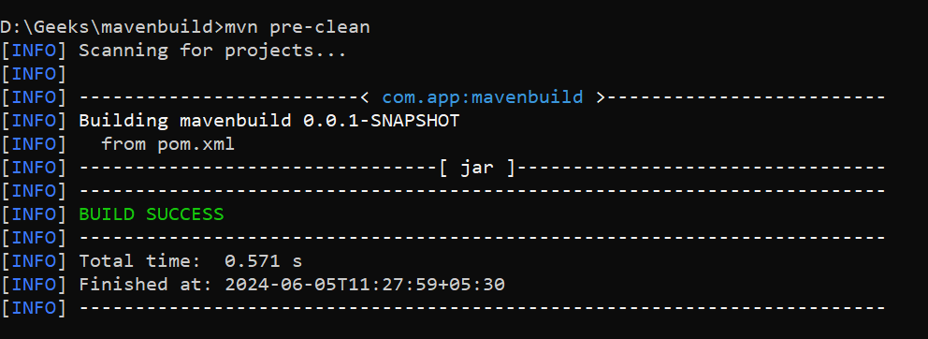

2. Removes files generated by the previous build:

**mvn clean**

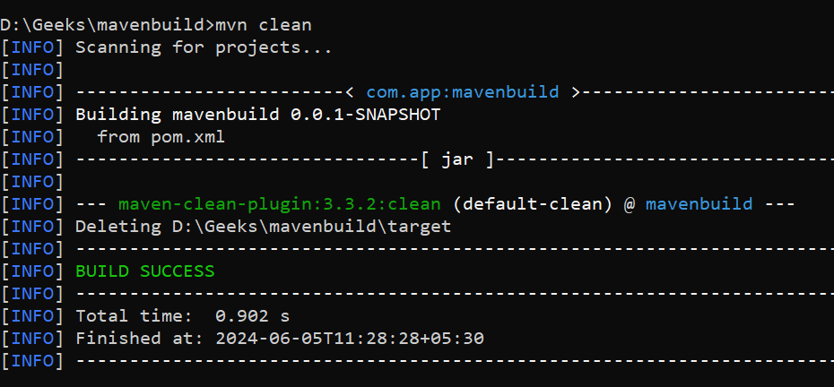

3. Executes processes needed after cleaning:

**mvn post-clean**

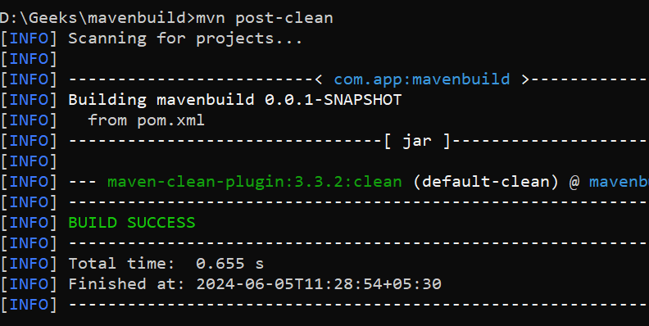

**Example 3: Site Lifecycle**

In this example, we explain the Site Lifecycle phases. Follow the steps below:

1. Executes processes needed before generating the site documentation.

**mvn pre-site**

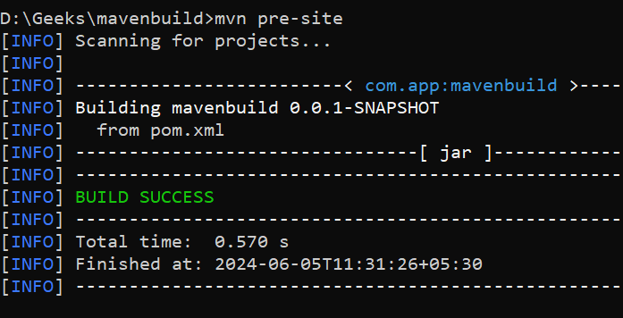

2. Generates the project’s site documentation

**mvn site**

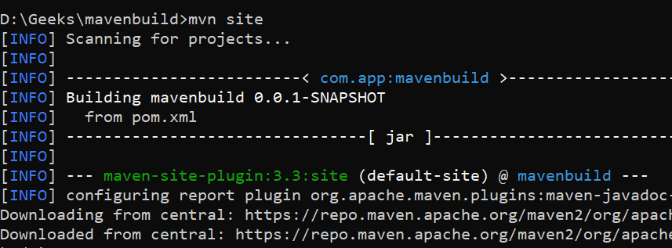

3. Executes processes needed after generating the site documentation

**mvn post-site**

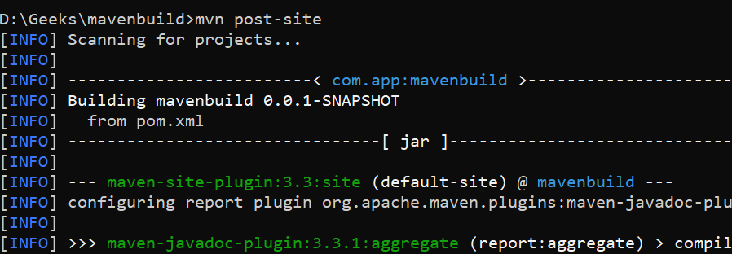

4. Deploys the generated site documentation to a web server

**mvn site-deploy**

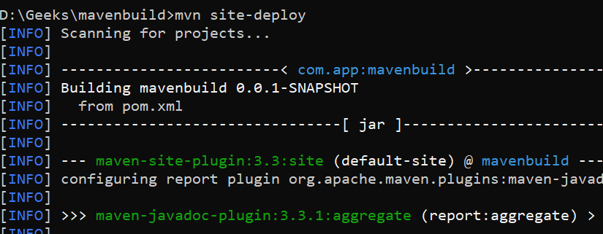

===================================================================================

1. **Maven Build Phases and Commands:**

Maven build phases are a sequence of steps or stages that Maven follows when executing a build lifecycle. These build phases are standardized and define the order in which Maven executes various goals. Each build phase represents a different stage in the lifecycle of a project.

Below are the standard Maven build phases:

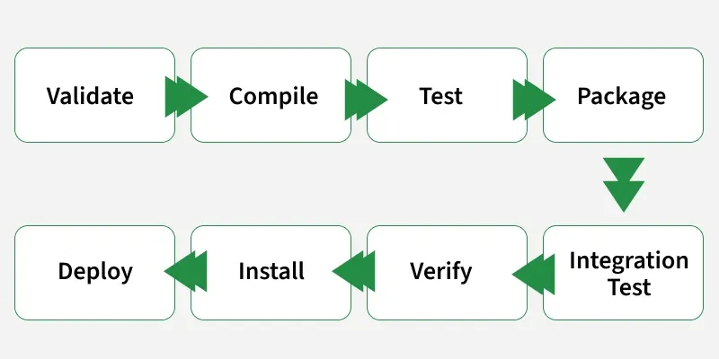

* **Validate:**This step validates if the project structure is correct. For example - It checks if all the dependencies have been downloaded and are available in the local repository.
* **Compile:**It compiles the source code, converts the .java files to .class, and stores the classes in the target/classes folder.
* **Test:**It runs unit tests for the project.
* **Package:**This step packages the compiled code in a distributable format like JAR or WAR.
* **Integration test:**It runs the integration tests for the project.
* **Verify:**This step runs checks to verify that the project is valid and meets the quality standards.
* **Install:**This step installs the packaged code to the local Maven repository.
* **Deploy:**It copies the packaged code to the remote repository for sharing it with other developers.

**Maven Commands:**

* **mvn clean:**Cleans the project and removes all files generated by the previous build.
* **mvn compile:**Compiles source code of the project.
* **mvn test-compile:**Compiles the test source code.
* **mvn test:**Runs tests for the project.
* **mvn package:**Creates JAR or WAR file for the project to convert it into a distributable format.
* **mvn install:**Deploys the packaged JAR/ WAR file to the local repository.
* **mvn site:**generate the project documentation.
* **mvn validate:**validate the project's POM and configuration.
* **mvn idea:idea:**generate project files for IntelliJ IDEA or Eclipse.
* **mvn release:perform:**Performs a release build.
* **mvn deploy:**Copies the packaged JAR/ WAR file to the remote repository after compiling, running tests and building the project.
* **mvn archetype:generate:**This command is used to generate a new project from an archetype, which is a template for a project. This command is typically used to create new projects based on a specific pattern or structure.
* **mvn dependency:tree:**This command is used to display the dependencies of the project in a tree format. This command is typically used to understand the dependencies of the project and troubleshoot any issues.

******************************************************************************************************************************************************************************************************************************************************************************************

**Section 2: Maven Installation**

* 1. **Install Apache Maven on Windows:**

**How to Install Maven on Windows?**

**Step 1: Download Maven Zip File and Extract**

* 1. Click on the Download button.
  2. Click on the apache-maven-3.8.4-bin.zip button.
  3. Now check for the executable file in downloads in your system
  4. Now right-click on the file and click on extract here to extract the file.
  5. After extracting, you get the extracted folder.
  6. Now copy the extracted folder.
  7. Now paste the copy folder in your windows drive in the Program files folder.
  8. Now the Permission Windows appears to paste the folder in program files then click on “Continue”.
  9. Now open the folder apache maven.
  10. Now after opening the folder then copy the address of the folder in program files.

**Step 2: Add MAVEN_HOME System Variable**

1. Now click on Start Menu and search “Edit the system environment variables” and open it.
2. After opening System, Variable New window appears, and click on “Environment Variables…”
3. Now click on New under user variable.
4. Now you can write any variable name and then paste the address we copy from program files in the variable value and then click on OK.

**Step 3: Add MAVEN_HOME Directory in PATH Variable**

1. Now go to the “System variables” Path option and double click on Path or Click on the Edit button.
2. Now click on New Button.
3. After New Paste the address we copy from program files to new.
4. After pasting the address add the \bin in the last and then click on OK.
5. Now click on the OK button.
6. Click on the OK button.

**Step 4: Verify Maven Installation**

1. Now your Apache Maven is installed on your computer. You may check by going to the “Start” menu typing Command Prompt. Open it.
2. When the Command Prompt opens, type mvn -version and click the enter button on the keyboard.
3. Now command prompt shows the version of Apache Maven installed on your windows.

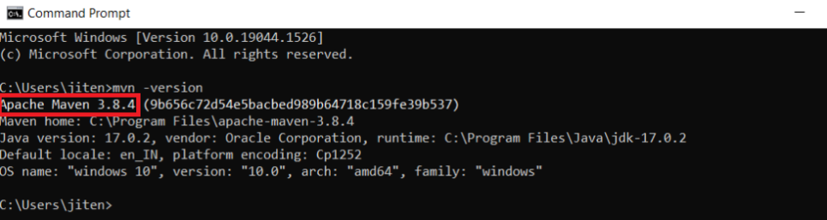

===================================================================================

* 1. **Setting the Java Version in Maven:**

Setting the Java version in Maven is important for ensuring compatibility and proper compilation of our project. By configuring the Maven Compiler Plugin in the pom.xml file, we can specify both the source and target Java versions. This ensures that our project is compiled using the desired Java version. It allows us to leverage its features while maintaining compatibility with our target environment.

Before changing the Java version in Maven, it's essential to check the current version of Java in Maven. For that, we have Maven commands.

**mvn –version**

**Output:**

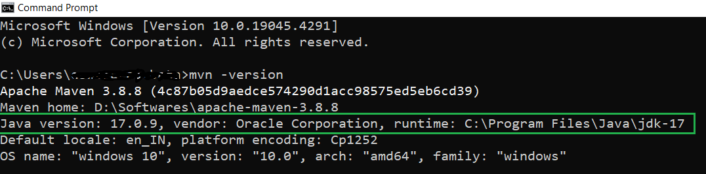

We have current maven version 3.8.8 with java version 17. Now we are change java version to 17 to 21.X for this we need specify the required java version in the compiler plugin in the pom.xml file. We changing java version in the maven by using Compiler Plugin.

**Changing Java Version in Maven Using Compiler Plugin:**

**Step 1: Create Maven Project**

First create a maven project, once project is successfully created then open **pom.xml**file from your project folder.

**Step 2: Locate Configuration Code**

Now locate the below configuration code in the **pom.xml**file.

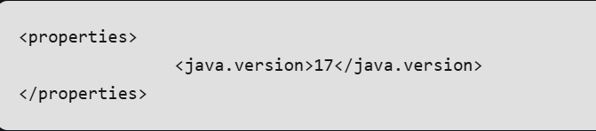

**Step 3: Modify Java Version**

Currently we have Java version 17. Now, we change this version to 21.X by modifying the version of Java to the desired version by updating the value within the <java.version> tag.

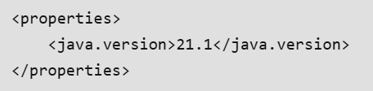

**Step 4: Update and Run the Project**

Now, update the project by using maven update project option, and run this project. After that observe the Java version in the Java console with logs.

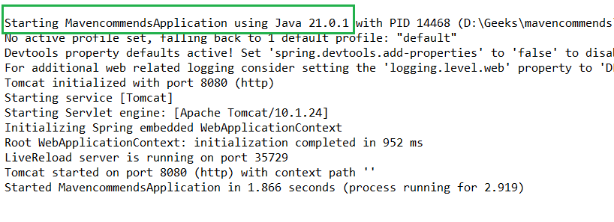

******************************************************************************************************************************************************************************************************************************************************************************************

**Section 3: Maven Project Setup**

* 1. **Maven Project in IntelliJ IDEA:**

IntelliJ IDEA is an integrated development environment (IDE) written in Java and developed by JetBrains. It is widely used for developing computer software. We will see the steps to create a Maven project in IntelliJ IDEA, from initial project setup to managing dependencies, building your project, and running tests.

Steps:

**Step 1:**  Open your IntelliJ IDE and go to **File > New > Project**. This will allow you to create a new project in IntelliJ.

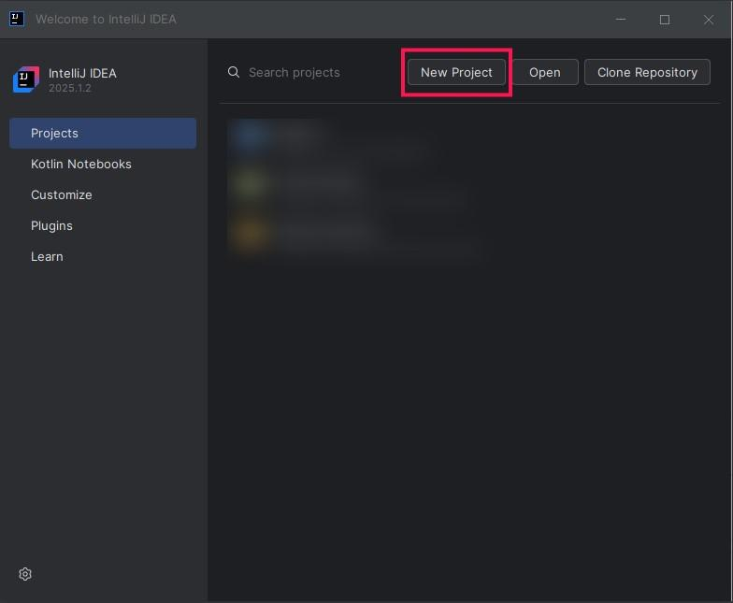

**Step 2:** We can also create project from existing ongoing project with the**New> project**option.

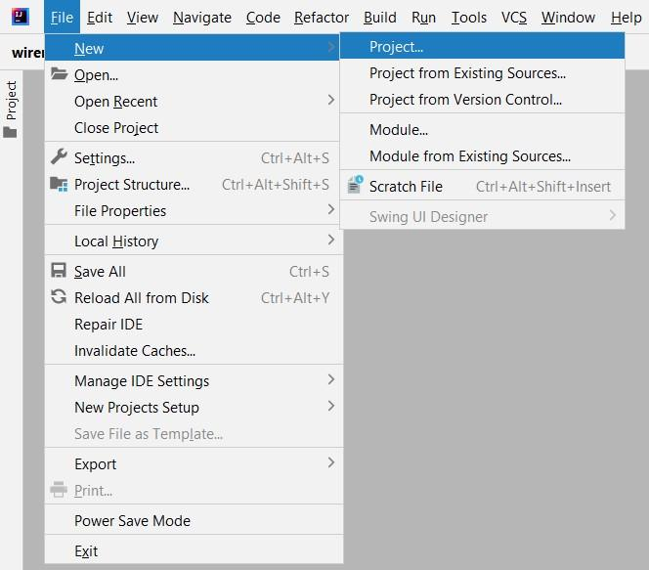

**Step 3:** After selecting Create New Project. In the New Project window, choose Maven as your project type. Then, select the appropriate JDK version from the Project SDK dropdown. Under the Archetype section, choose**maven-archetype-quickstart**, which is a simple template for a basic Java application.

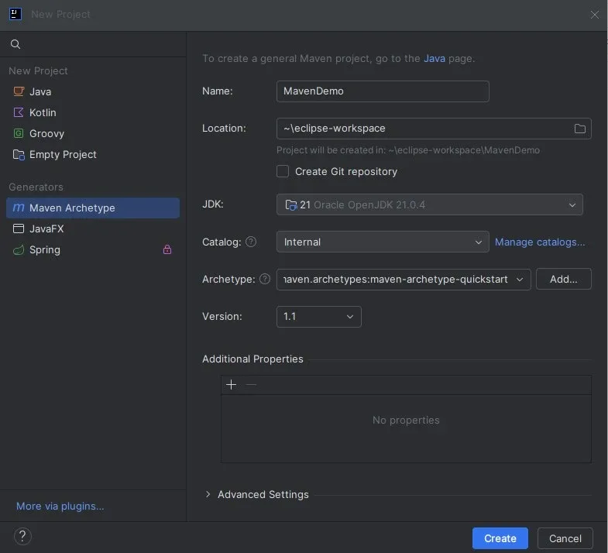

1. Select the directory where you want to save the project and click **Finish**.

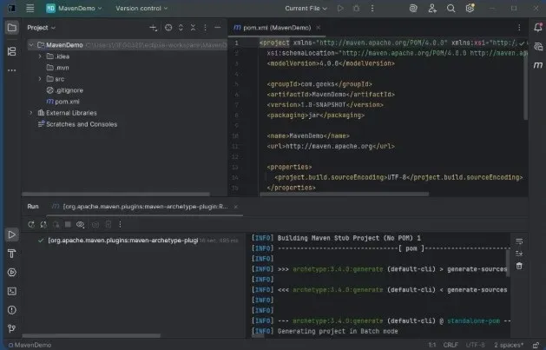

**Understand the Maven Project Structure:**

* **src/main/java**: Contains the Java source code files.
* **src/main/resources**: Holds non-Java resources like configuration files.
* **src/test/java**: Contains test classes.
* **pom.xml**: The most important file in a Maven project that defines the project’s structure, dependencies, and build configurations.

===================================================================================

* 1. **Maven Project in Eclipse IDE:**

Steps:

**Step 1: Create A New Maven Project**

First, we will create a new Maven project. For this, we will open our Eclipse IDE, then go to File > New > Maven Project.

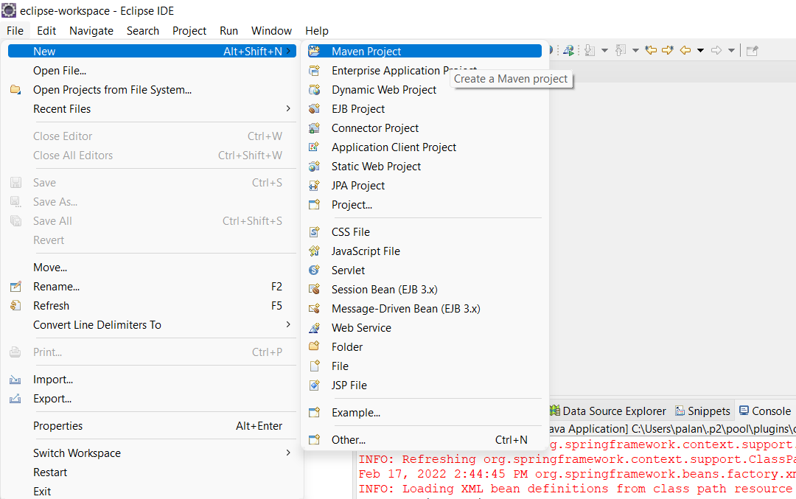

Once we click on Maven Project we will get a prompt for setting up our Workspace location.

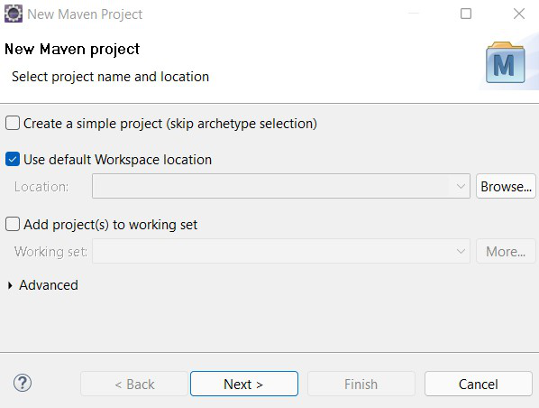

After setting Workspace location according to our choice. We will click on Next to go to further project setup steps.

**Step 2: Setting Up Archetype**

In this step, we will setup the archetype for our maven project. Archetype is a templating toolkit. It provides a templating solution for your project and helps to create a sample project structure that you can extend based on your business requirements. For this tutorial, we will use the **maven-archetype-j2ee-simple** archetype for our project.

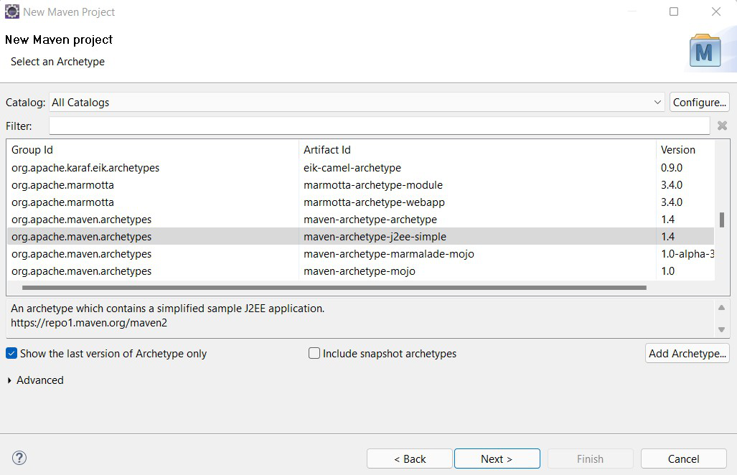

After choosing the archetype we will click on Next and it will ask for the details like Group Id, Artifact Id, and Package information.

* Group Id - It's a unique identifier to uniquely identify the project in a maven repository.
* Artifact Id - It's basically the project name.

We will be using the following details:

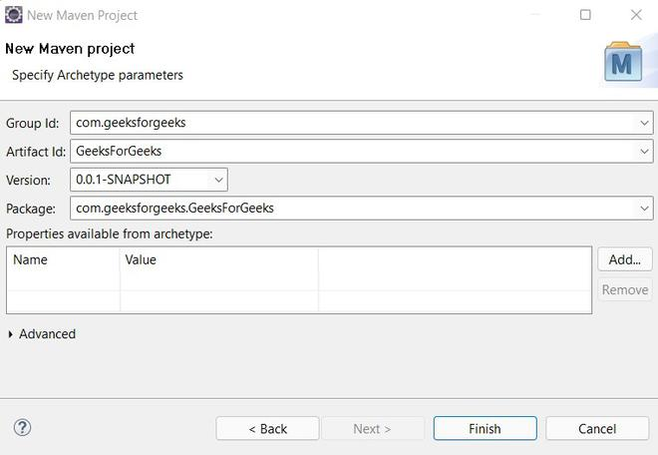

After adding all these details we need to click on the Finish button. Maven will start creating your project and after a few seconds, your project will be created.

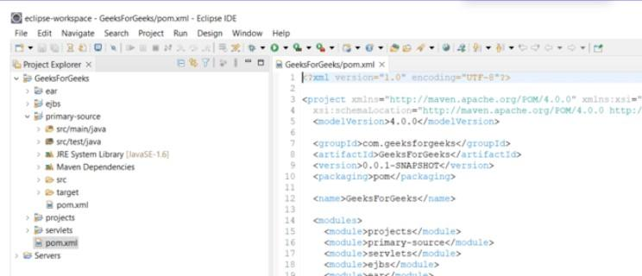

===================================================================================

* 1. **Create an Executable JAR:**

The Maven is a powerful build automation tool primarily used for java program projects. And It simplifies that build process, dependency management and project configuration through a standard project object model which means POM file.

A JAR file is one of the package file formats typically used to aggregate many Java class files and associated metadata and resources into one file for distribution. JAR files are archive files that include a Java-specific manifest file. Creating an executable JAR file with Maven can be done in several ways. Basically, the executable JAR file contains a main class with a main method and includes all the dependencies required to run the application.

**Create an Executable JAR with Maven**

For creating Executable JAR we have some ways below listed them.

* Using the Maven Assembly Plugin.
* Using the Maven Shade Plugin.
* Using the Maven Jar Plugin.
* Using maven Commands.

**Tools and Technologies**

* Java Programming
* Java Version 17
* Maven 3.X.X
* JUnit
* Spring Tool Suite

**Steps to Create an Executable JAR with Maven:**

**Step 1:** Create a Maven project by using Spring Tool Suite with basic dependencies.

**Step 2:** Once project created successfully, now observe the project folder structure. The maven tool can provide standard structure to understand the project structure easily.

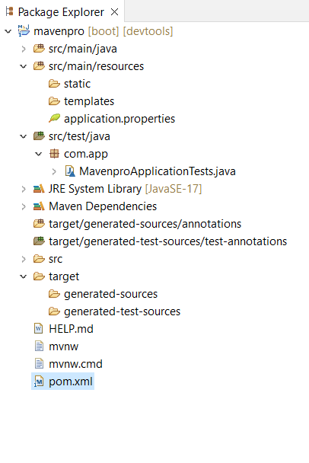

**Step 3:** Now located the pom.xml file open It now observe the dependencies in that file. This file contains information like project configuration, dependency management and other project related information.

**Step 4:** Now change the **pom.xml** file for creating executable JAR with maven below we provide the required XML configuration.

**Using the Maven Assembly Plugin:**

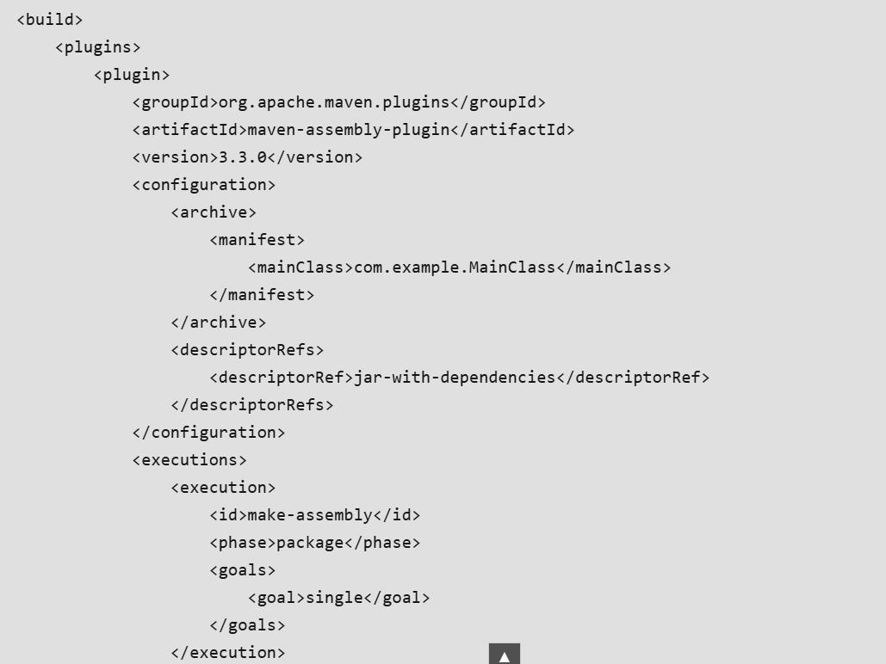

Now update the Maven Project after this run this project as Spring Boot App. Now refresh the project folder there is JAR is created.

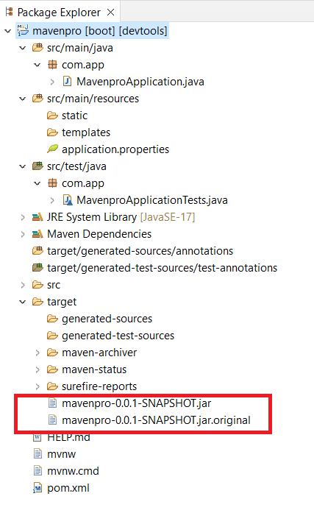

**Step 5:**

In this step we use another approach to create an Executable JAR with Maven. Update the below configuration code in the **pom.xml**and update the project run this project.

**Using the Maven Shade Plugin:**

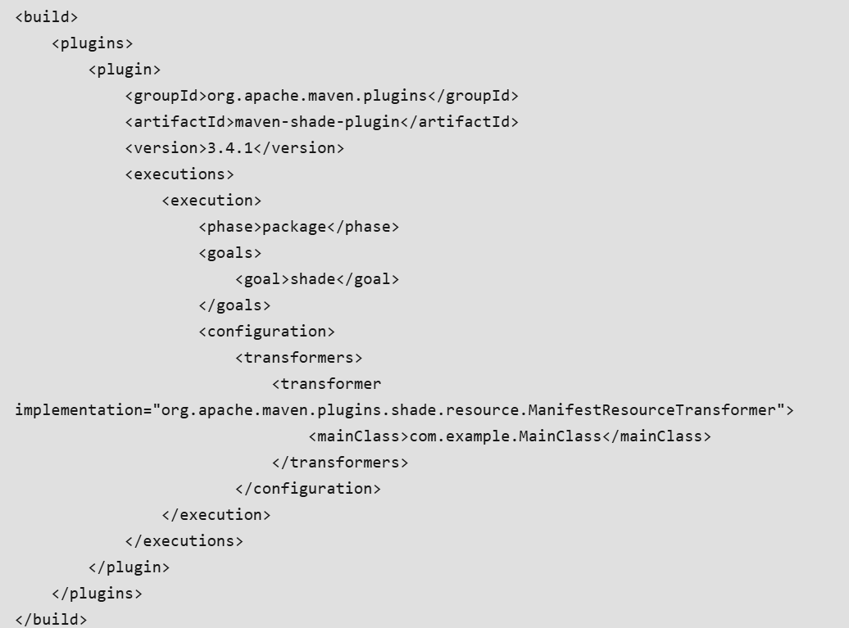

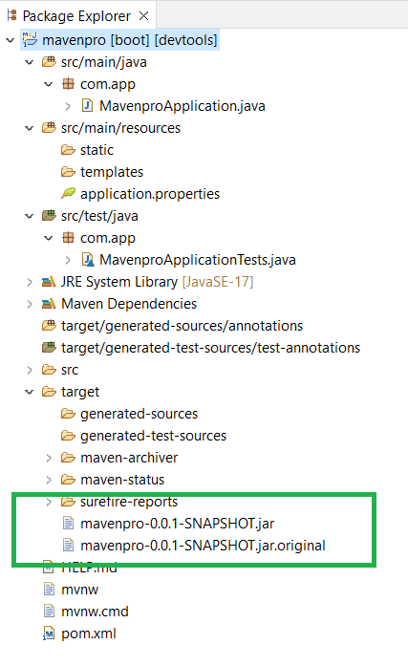

**Step 6:** In this step we use maven command to Create an Executable JAR with Maven that is

**mvn clean package**

To Create an Executable JAR with Maven command we need redirect into project folder by using **CD**command then run the above mention command after this refresh the project folder then you can observe the jar files in the project folder.

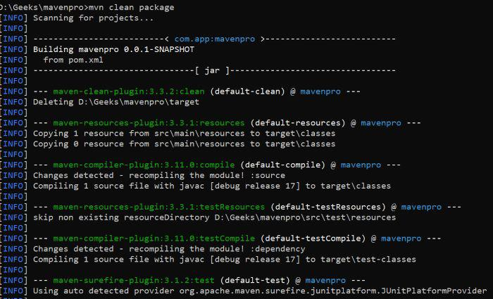

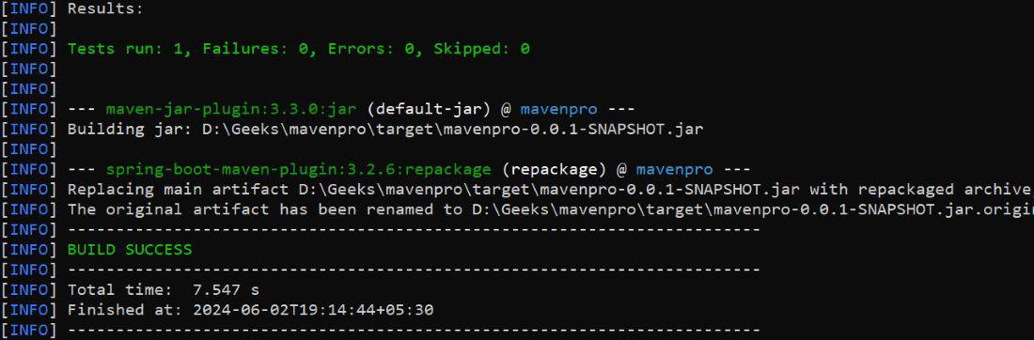

===================================================================================

* 1. **Multi-Module Project:**

A multi-module project in Maven allows you to manage a collection of related projects in a single build. This approach is particularly useful for large applications where different modules have distinct functionalities but need to be managed, built, and deployed together. By using the parent POM (Project Object Model), you can streamline dependency management, version control, and build processes.

In a multi-module Maven project, you have a parent POM that manages the configurations and dependencies for the entire project. Each module within the project has its own POM file and can be built independently or as part of the larger project. The parent POM typically resides in the root directory, while the modules are in subdirectories.

**Key Benefits:**

* **Centralized Dependency Management:** Manage dependencies in one place.
* **Modularization:** Break down the project into smaller, manageable parts.
* **Reusability:** Share common code across different modules.
* **Consistent Build Process:** Use a single command to build all modules.

**Key Terminologies**

* **Parent POM (Parent Project Object Model):** The POM file that acts as the parent for one or more child modules, centralizing configurations and dependencies inherited by the child modules.
* **Child Module:** A sub-project of the parent POM, each with its own POM file and directory structure.
* **Module:** A sub-project within a multi-module Maven project. Each module has its own POM file and is treated as a separate Maven project.
* **Packaging:** The type of artifact that Maven will produce, like JAR, WAR, and POM.
* **Dependency Management:** The section in the parent POM that specifies the versions and configurations used in the child modules.
* **Plugin Management:** The section in the parent POM that defines the plugin configurations, versions, and settings used by the build process.
* **Plugin:** A tool or extension that performs specific tasks during the build process.
* **Artifact:** The package output of the Maven build, such as a JAR, WAR, or ZIP file

**Implementation of Multi-Module Project with Maven:**

**Step 1: Create the Parent Module**

Create a Maven archetype project using IntelliJ IDEA with the following options:

* Name: parent-module
* JDK: 17
* Archetype: maven-archetype-quickstart

Click on the **Create**button.

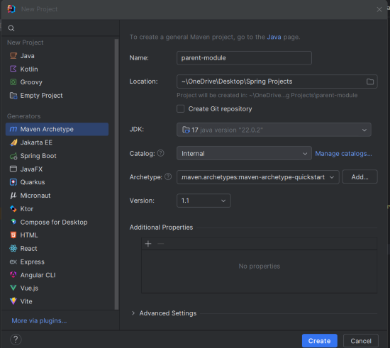

**Step 2: Create the Child Module1**

Create another Maven archetype project using IntelliJ IDEA with the following options:

* Name: child-module1
* JDK: 17
* Archetype: maven-archetype-quickstart

Click on the **Create**button.

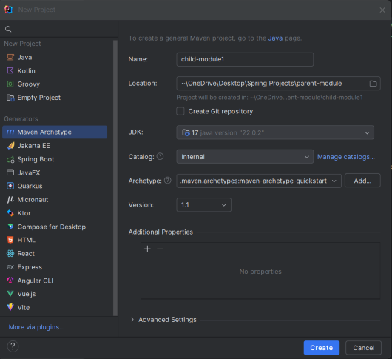

After creating the**child-module1** project, the file structure will look like the below image.

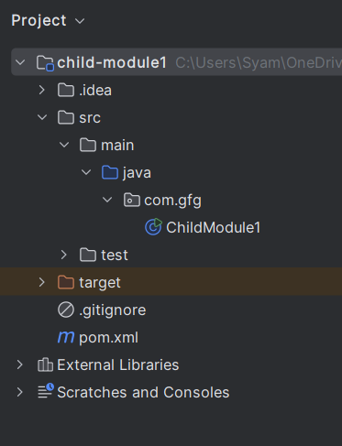

**Step 3: Create the ChildModule1 Class**

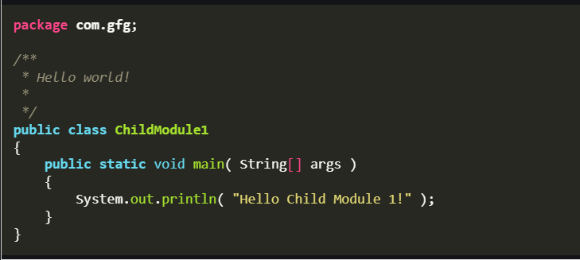

**pom.xml for child-module1:**

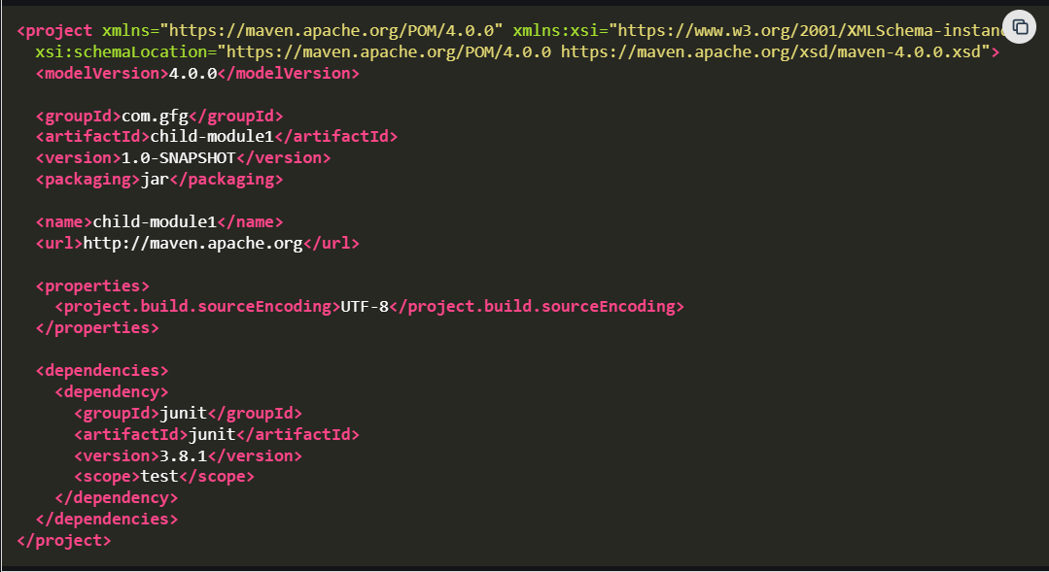

**Step 4: Create the Child Module2**

Create another Maven archetype project using IntelliJ IDEA with the following options:

* Name: child-module2
* JDK: 17
* Archetype: maven-archetype-quickstart

Click on the **Create**button.

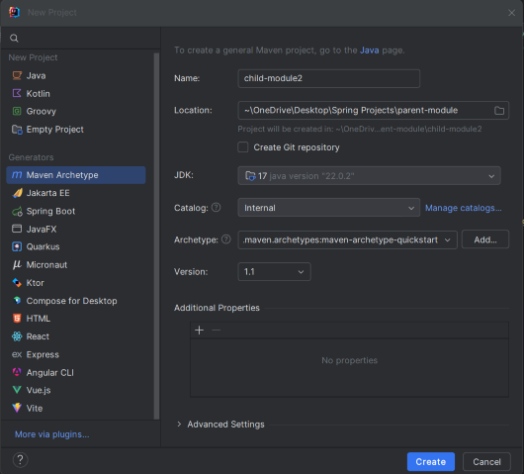

After creating the child-module2 project, the file structure will look like the below image.

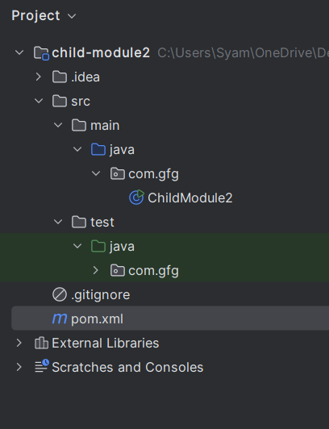

**Step 5: Create the ChildModule2 Class**

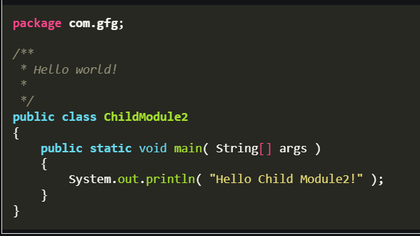

**pom.xml for child-module2:**

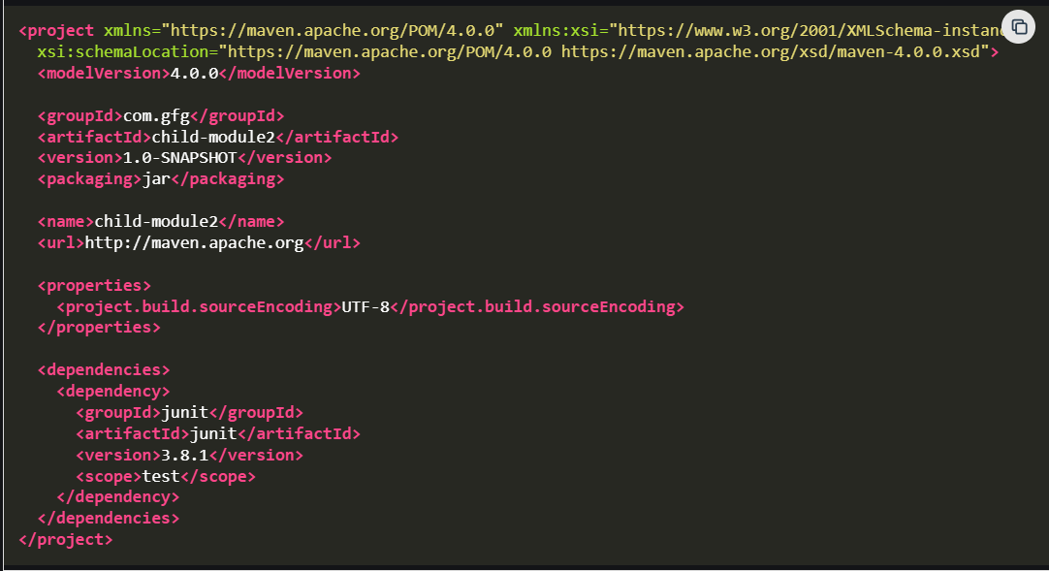

**Step 6: Parent File Structure**

After setting up the child modules, the parent file structure should look like this:

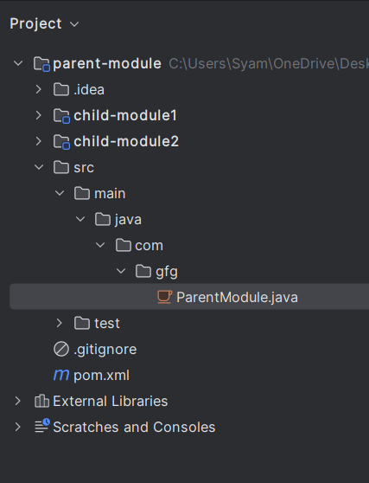

**Step 7: Add Spring Starter to parent pom.xml**

Add the Spring starter dependency to the parent pom.xml:

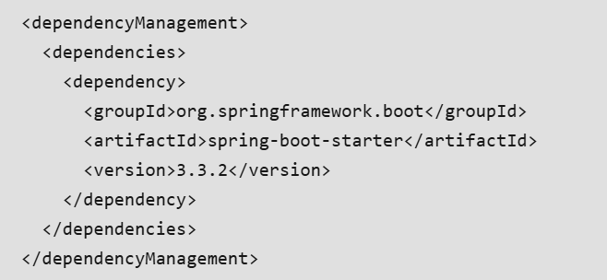

**Step 8: Add Maven Plugin**

Add the Maven compiler plugin to the parent pom.xml:

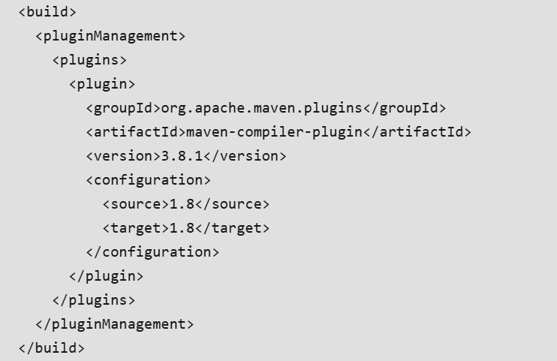

**Step 9: Add the Child Modules**

Add the child modules to the parent pom.xml:

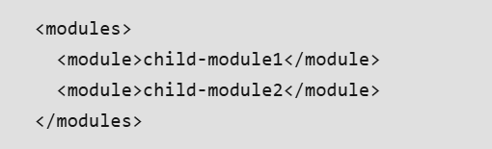

**Parent pom.xml:**

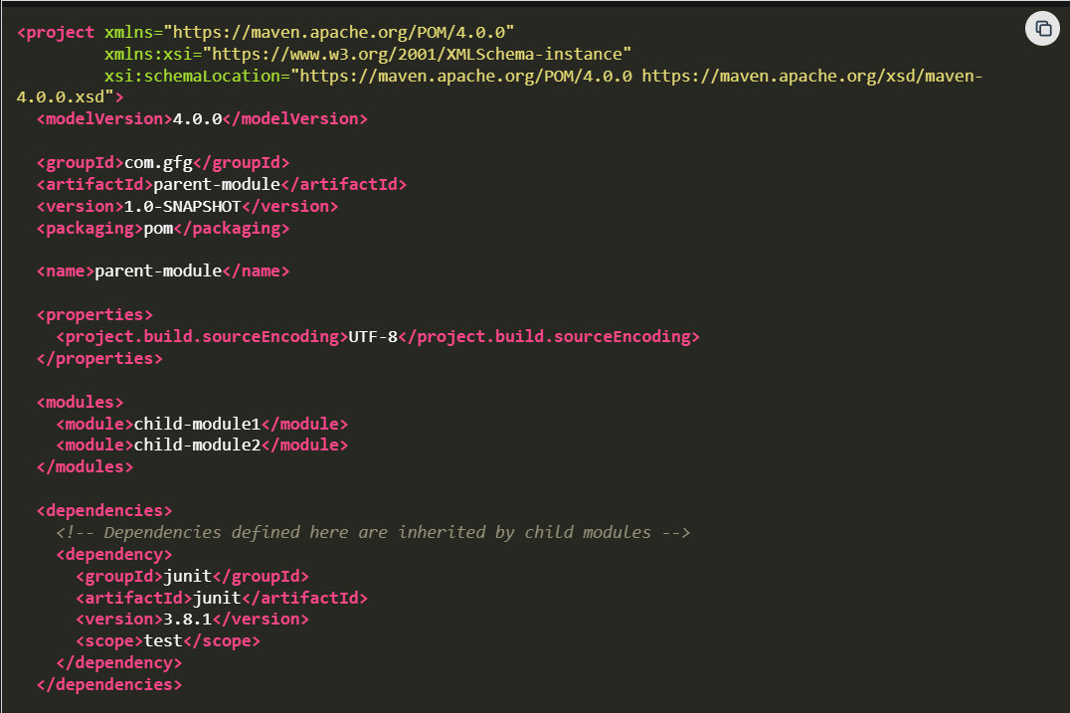

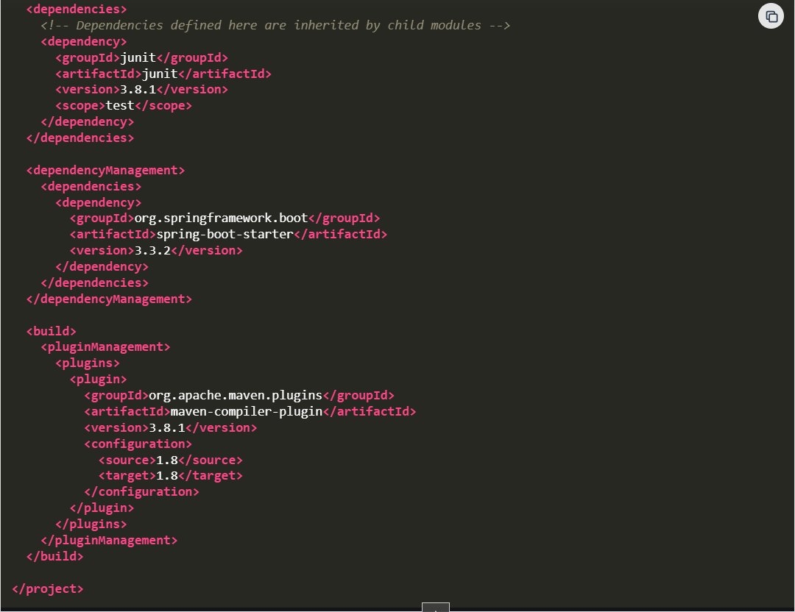

**Step 10: Create the ParentModule Class**

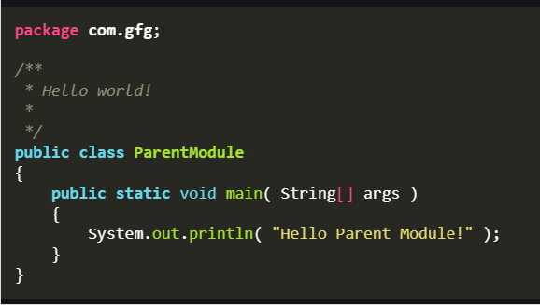

**Step 11: Install the Maven**

Use the following command to install the Maven of the parent module:

mvn clean install

**Output:**

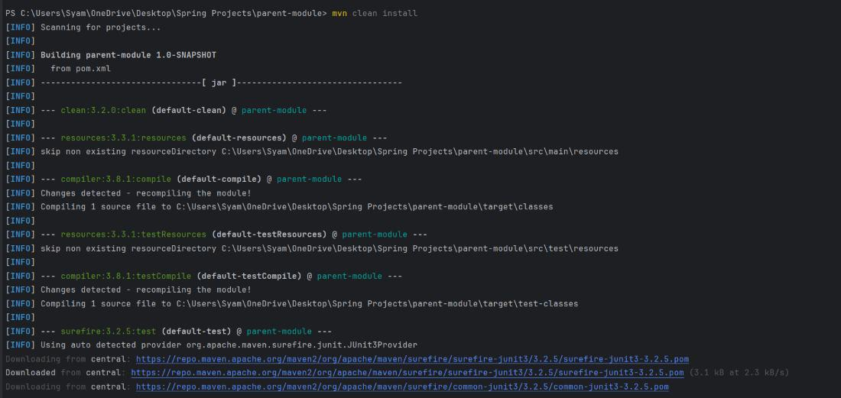

**Test Result:**

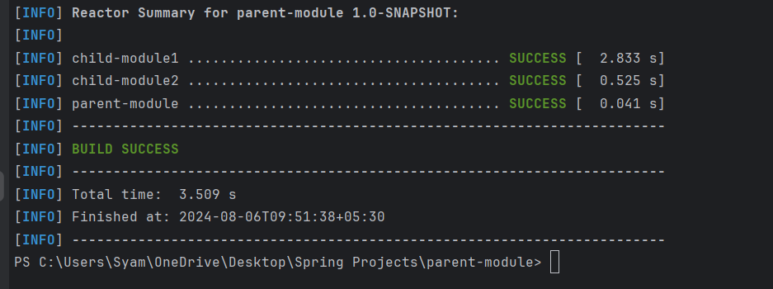

**Step 12: Run Child Module1**

Use the following command to run Child Module1:

**java -cp target/classes com.gfg.ChildModel1**

**Output:**



**Step 13: Run Child Module2**

Use the following command to run Child Module2:

**java -cp target/classes com.gfg.ChildModel2**

**Output:**



******************************************************************************************************************************************************************************************************************************************************************************************

**Section 4: Maven POM (Project Object Model)**

* 1. **Maven POM:**

The **pom.xml** file defines the project structure, dependencies, build configurations, and plugins required to compile, test, and deploy your application. Maven pom file helps to build and manage your project by defining things.

**Pom.xml components:**

**1. Project Information Section (<project>):**

This is the root tag of the POM file, which defines the project’s basic information.

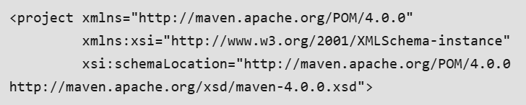

Inside the <project> tag, you'll find metadata that Maven uses to identify and build your project.

**2. Project Coordinates Section**

The project coordinates define the **group ID**, **artifact ID**, and **version**that uniquely identify your project in a Maven repository.

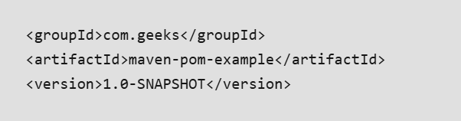

* **groupId**: Your organization's domain, usually in reverse.
* **artifactId**: The name of your project or library.
* **version**: The version number of your project.

**3. Dependencies Section**

This is where you define external libraries or dependencies required for your project. These dependencies are fetched from a repository (such as Maven Central) when you build your project.

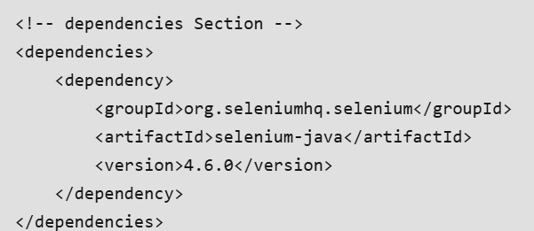

Each Dependency include:

* **groupId**: The organization or group that maintains the library.
* **artifactId**: The name of the library or dependency.
* **version**: The specific version of the dependency.

**4. Build Section:**

The Build Section in a project configuration (like Maven or Gradle) defines how your project is compiled, tested, and packaged.

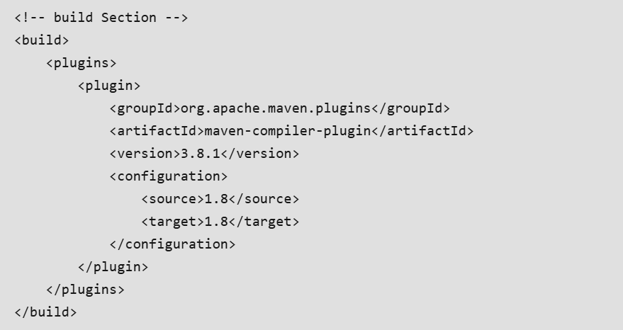

* **Plugins**: Tools that perform tasks like compiling code, running tests, generating reports, etc.
* **Plugin Configuration**: Customizes how the plugin behaves, such as setting specific options.

**5. Repositories Section:**

This section specifies the repositories where Maven should fetch dependencies from. While Maven defaults to the Maven Central Repository, you can configure additional repositories as needed.

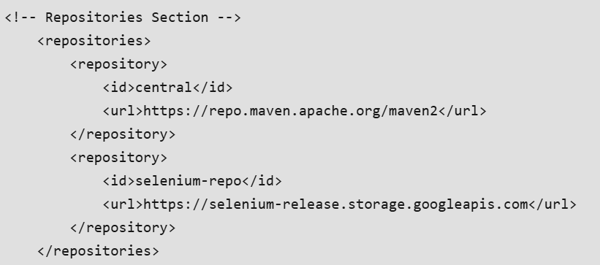

**6. Profiles Section:**

The Profiles Section in Maven allows you to define different configurations for various environments, like development, testing, or production. Each profile can specify unique dependencies, properties, and goals for specific tasks.

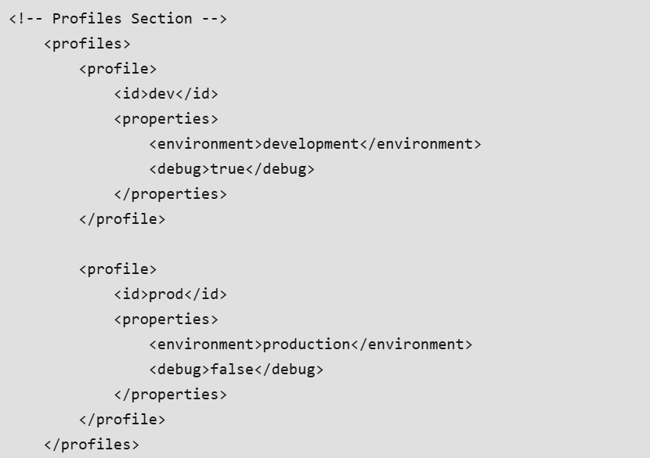

**7. Properties Section**

Properties in Maven allow you to define variables in your pom.xml file, which can be reused throughout the file. This helps maintain consistency and makes it easier to update values in one place.

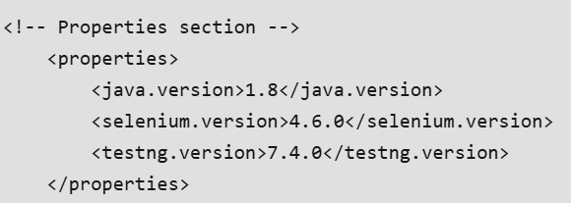

**Workflow:**

Here is the workflow of a Maven POM file in any Maven project:

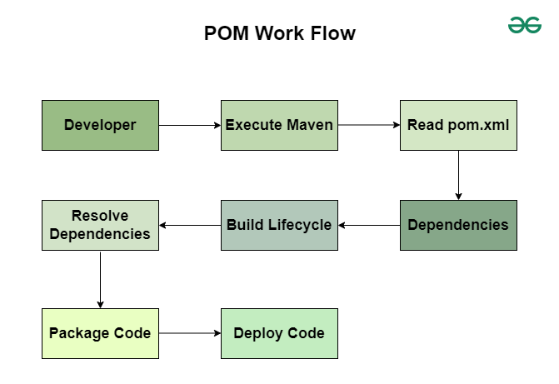

1. **Initialization:**The Maven reads the pom.xmlfile and initializes the build process.
2. **Dependency Resolution:**Downloads the Specified dependencies from remote repositories.
3. **Build Life cycle Execution:**Executes the build life cycle phases like compile, test, package, verify and other phases.
4. **Plugin Execution:**Runs the configured plugins for various takes like code analysis and other tasks.
5. **Packaging:**Packages the compiled code into specified format like JAR, WAR and other formats.
6. **Deployment:**Deploys the packaged code to a remote repository or serve

===================================================================================

* 1. **Difference Between Super, Simplest, and Effective POM:**

**POM (Project Object Model)** is the fundamental unit in Maven. **POM** is an **XML file** containing project information and configuration parameters that Maven will use to build the project. It includes default values for most projects.

**POM Example:**

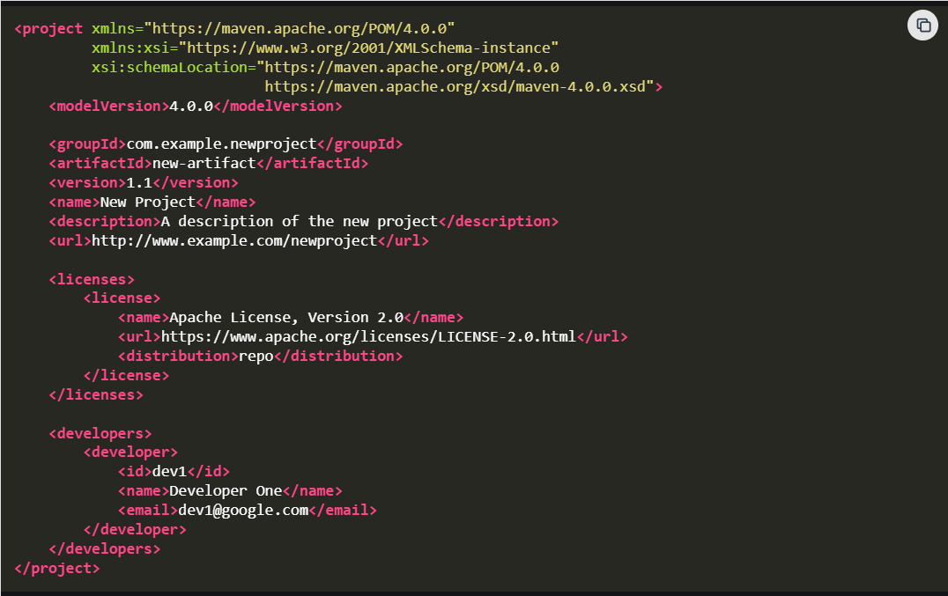

**Explanation:**

This POM file defines a Maven project with the group ID "com.example.newproject" and artifact ID "new-artifact" at version "1.1". It includes metadata such as the project name "New Project," a description, and the project URL. Additionally, it specifies the Apache License 2.0 and lists one developer with the ID "dev1", name "Developer One," and email "dev1@google.com".

**Super POM:**

Super POM is Maven's default POM and every POM inherits from a parent or default. This comprises values inherited by default. Maven uses an effective POM (configuration from super pom plus project configuration) to carry out essential goals.  
This POM file configures a Maven project by specifying repositories for dependencies and plugins, customizing build directories, and managing plugins for build tasks. It also defines a release profile that activates based on a property, enabling specific plugins for creating source and Javadoc JARs during the release build process.

**Simplest POM:**

The simplest POM is the one you define in your Maven project. To declare a POM, you must specify at least four elements: model version, groupId, artifactId, and version. The simplest POM will inherit all of the configurations from the super POM.

**Configuration of Dependencies, Repositories, Plugin, and Build in Simplest POM:**

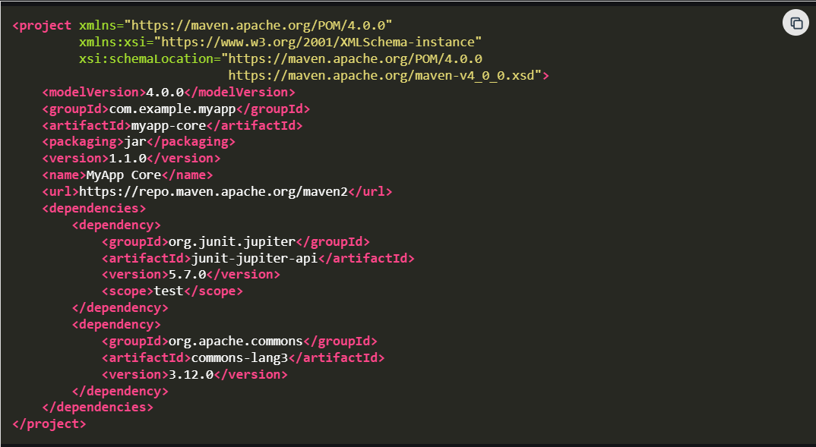

**Explanation:**

This POM file configures a Maven project with essential details such as the group ID, artifact ID, packaging type, and version. It includes the project name and URL for the Maven central repository. The dependencies section specifies two dependencies: JUnit for testing (test scope) and Apache Commons Lang for utility functions.

**Effective POM:**

Effective POM combines all the default settings from the super POM file with the configuration specified in our POM application. Maven does not just employ Simplest POM (pom.xml) to generate our project. It requires all of the default settings to compile. It will use the default setup until the developer overwrites these settings.

This POM file defines a Maven project with essential details such as group ID, artifact ID, version, packaging type, name, and description. It specifies the Apache License, version 2.0, and includes one developer with the role of "developer". The dependencies section includes spring-core for core Spring functionality and junit for testing. The build section configures three Maven plugins: maven-compiler-plugin for Java compilation, maven-surefire-plugin for running tests, and maven-jar-plugin for packaging the project into a JAR file. The repositories section includes the central Maven repository for both dependencies and plugins.

**Difference Between Super, Simplest, and Effective POM:**

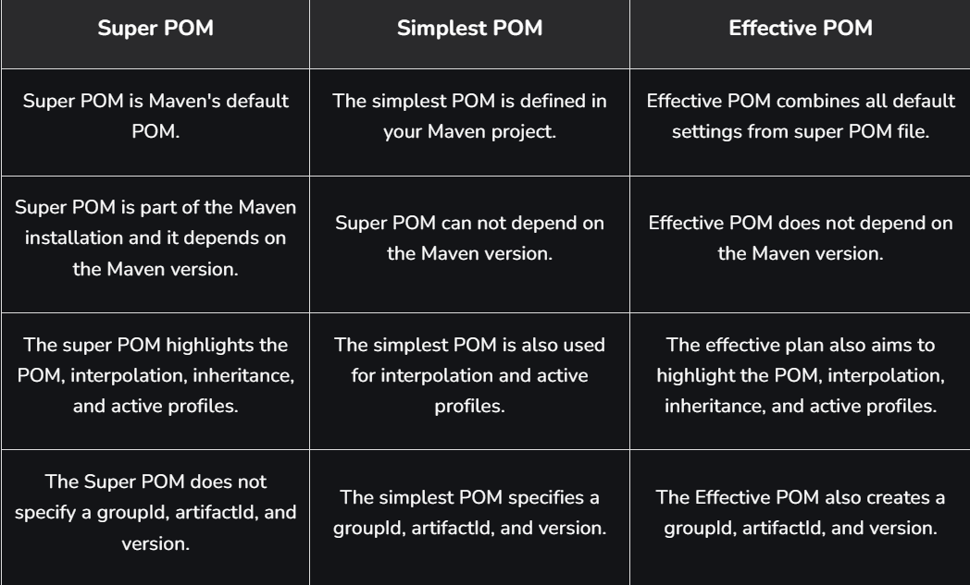

**==================================================================================**

* 1. **Default Values for Maven Properties:**

[**Apache Maven**](https://www.geeksforgeeks.org/devops/apache-maven/)**properties are key-value pairs that can be used to configure various of the build process. These properties can be defined in several places such as in the POM file, Settings file, or with the command line. Maven provides a set of default properties that are available for use in any Maven Project.**

**Default Maven Properties:**

* ${basedir}: The absolute path to the directory containing the POM file
* ${project.build.directory}: The directory where the project is built.
* ${project.build.outputDirectory}: The directory where compiled classes are placed.
* ${project.build.testOutputDirectory}: The directory where compiled test classes are placed.
* ${project.groupId}: The group ID of the project.
* ${project.artifactId}: The artifact ID of the project.
* ${project.version}: The version of the project.
* ${project.packaging}: The packaging type of the project.
* ${project.build.sourceDirectory}: The directory containing the source code.
* ${project.build.testSourceDirectory}: The directory containing the test source code.
* ${project.reporting.outputDirectory}: The directory where the project's reports will be generated.
* ${project.build.finalName}: The final name of the build artifact.

**Key Default Properties in the Maven Project:**

1. XML Version:

<?xml version="1.0" encoding="UTF-8"?>

2. Group ID:

<groupId>org.springframework.boot</groupId>

3. Artifact ID:

<artifactId>spring-boot-starter-parent</artifactId>

4. Version:

<version>3.2.6</version>

5. Relative Path:

<relativePath /> <!-- lookup parent from repository -->

**\*\*\*\*\*\*\*\*\*\*\*\*\*\*\*\*\*\*\*\*\*\*\*\*\*\*\*\*\*\*\*\*\*\*\*\*\*\*\*\*\*\*\*\*\*\*\*\*\*\*\*\*\*\*\*\*\*\*\*\*\*\*\*\*\*\*\*\*\*\*\*\*\*\*\*\*\*\*\*\*\*\*\*\*\*\*\*\*\*\*\*\*\*\*\*\*\*\*\*\*\*\*\*\*\*\*\*\*\*\*\*\*\*\*\*\*\*\*\*\*\*\*\*\*\*\*\*\*\*\*\*\*\*\*\*\*\*\*\*\*\*\*\*\*\*\*\*\*\*\*\*\*\*\*\*\*\*\*\*\*\*\*\*\*\*\*\*\*\*\*\*\*\*\*\*\*\*\*\*\*\*\*\*\*\*\*\*\*\*\*\*\*\*\*\*\*\*\*\*\*\*\*\*\*\*\*\*\*\*\*\*\*\*\*\*\*\*\*\*\*\*\*\*\*\*\*\*\*\*\*\*\*\*\*\*\*\*\*\*\*\*\*\*\*\*\*\*\*\*\*\*\*\*\*\*\*\*\*\*\*\*\*\*\*\*\*\*\*\*\*\*\*\*\*\*\*\*\*\*\*\*\***

**Section 5: Managing Dependencies with Maven:**

* 1. **Searching dependencies for a project:**

Maven is a build automation tool that is used for java projects for various activities like dependency management, building the project, documentation, unit testing, etc provided by Apache. One of the key activities of Maven is Dependency management because it's one of the most difficult jobs for developers to manage hundreds of dependencies and artifacts for multiple projects. Maven manages and gets these dependencies from repositories. There are mainly three types of repositories.

**Repositories Available in Maven**

**1. Local Repository**

This repository is located on your local workstation, and it's available on the C:\Users\<user_name>\.m2\repository for windows, the path may vary for other operating systems like MAC, Linux, etc. When we build a Maven project, all the required dependency jar files into this folder, and further reuse the same jars for other projects which requires the same dependencies.

**Settings.xml File:**

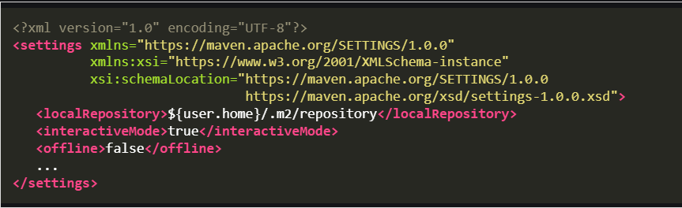

**2. Central Repository**

This is a remote repository available over the internet, whenever a dependency or artifact is not found in the local repository maven triggers a request to this central repository and downloads the dependencies to the local repository. This repository is provided by the Apache Maven group. The url for this central repo is listed as <https://repo.maven.apache.org/> There are multiple mirrors available for the central repo, one can make changes on the settings.xml file in maven to use a particular mirror that is officially listed. Some dependency uploads can also be made to the central repo after gaining some permissions.

**Settings.xml File:**

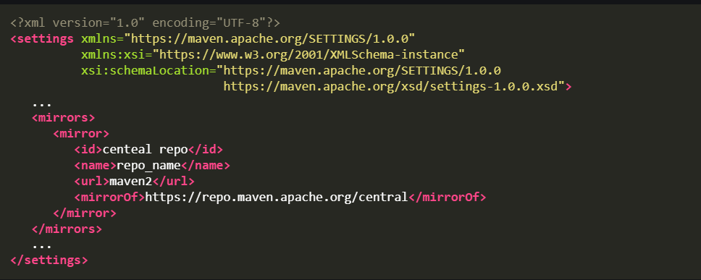

**3. Internal Repository**

These repositories are maintained by the organization where downloads from external sites are prohibited, the organizations can add the details of these internal repositories in the settings.xml file. These repositories are private to the respective organizations. The libraries which are missing on the central repository are added here. All the artifacts or project references that are developed by the organization exist here. The dependencies required are loaded from here and directly to the local repository. If maven can't find the required dependency from any of the following sources, it throws an error stating "cannot resolve dependency". To add a new internal remote URL

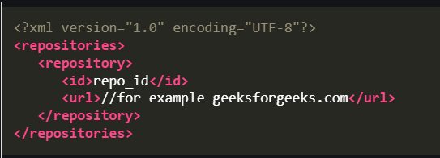

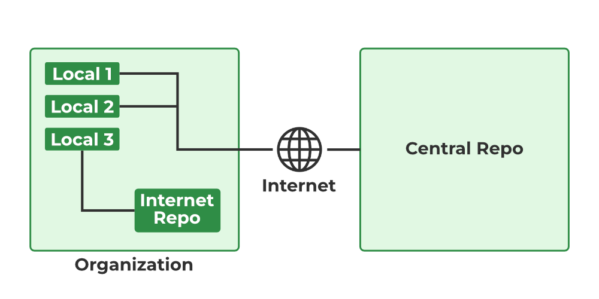

Here the third local machine has restricted access to external sites, so it uses the internal repo to find the dependencies.

===================================================================================

* 1. **Maven Dependency Scopes:**

Maven Dependency scopes are used to specify the visibility and life cycle of a dependency in a Maven project. In Maven we have six different dependency scopes. Below we explain them by using a pom.xml file.

* Compile Scope
* Provided Scope
* Runtime Scope
* Test Scope
* System Scope
* Import Scope

**Compile Scope:**

This is the default scope in the Maven. Dependencies with this scope are available in all class paths like compile, test, and runtime and are also packaged in the final artifact like JAR, WAR, and other formats.

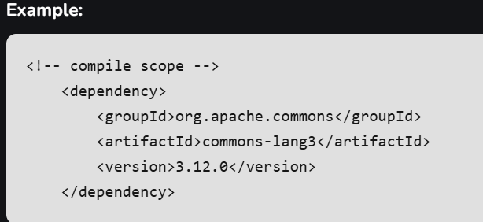

**Provided Scope:**

Dependencies with this scope are required for compiling the project code but are expected to be provided by the runtime environment. These Dependencies are not packaged with artifact.

**Example:**

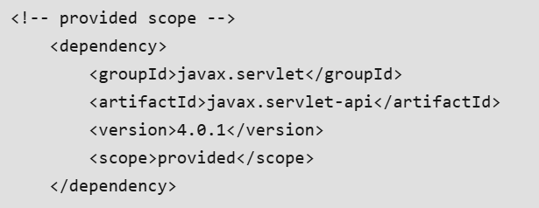

**Runtime Scope:**

Dependencies with this scope are need for execution of the source code but are not required for compilation. These dependencies are not included in the compilation classpath but are included in the runtime classpath and also these are packaged in the final artifact.

**Example:**

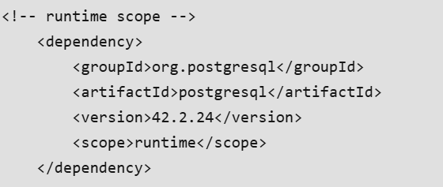

**Test Scope:**

Dependencies with this scope are only needed for compiling and running tests, not for the production code.

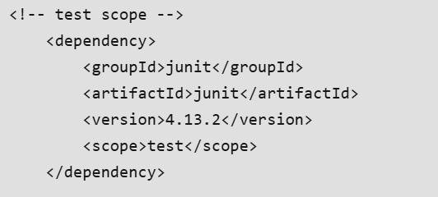

**System Scope:**

Dependencies with this scope are not retrieved from the Maven repository but are referenced from the local system. This scope is generally not recommended because it bypasses Maven's dependency management.

**Example:**

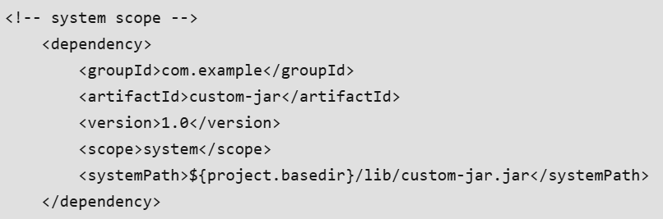

**Import Scope:**

This scope is used only in Maven 2.0.9 and above. It is used in a pom's dependency Management section to allow you to import dependency management information from other POM files into the current project.

**Example:**

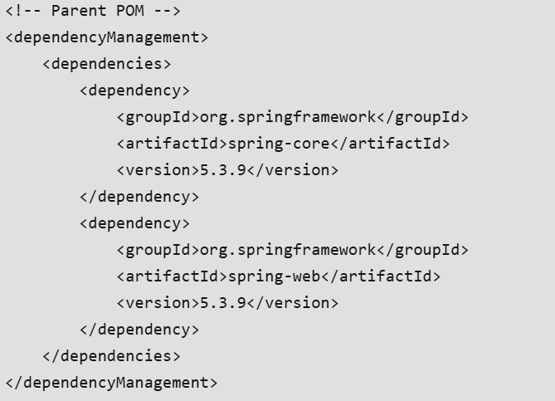

===================================================================================

* 1. **Maven - External Dependencies:**

**External dependencies in Maven** refer to the libraries or packages that your project relies on but are not part of your project's source code. Maven manages these dependencies by downloading them from remote repositories and adding them to your project's classpath during the build process. In this article, we will learn about **External Dependencies** in the Maven tool.

**Key Concepts of Maven External Dependencies:**

* Declare dependencies in the project's pom.xml using **<dependencies>** tags.
* Specify **group ID, artifact ID**, and**version** for each dependency.
* Optionally, set **dependency scope** (e.g., compile, test) using**<scope>**tags.
* Run Maven commands by using **mvn clean install**to download dependencies and build the project.

**Tools and Technologies:**

Below we provide the required tools and technologies to understand this article.

* Java Programming
* Apache Maven Tool
* Integrated Development Environment
* Maven Central Repository

**Prerequisites:**

* JDK
* Maven
* Basics of XML
* Basics of Java Programming

**Example of External Dependencies in Maven:**

**Step 1: Setup Maven Project and Dependencies**

First, we created a maven project. Below we provide required dependencies and Project folder structure for your reference.

**Dependencies:**

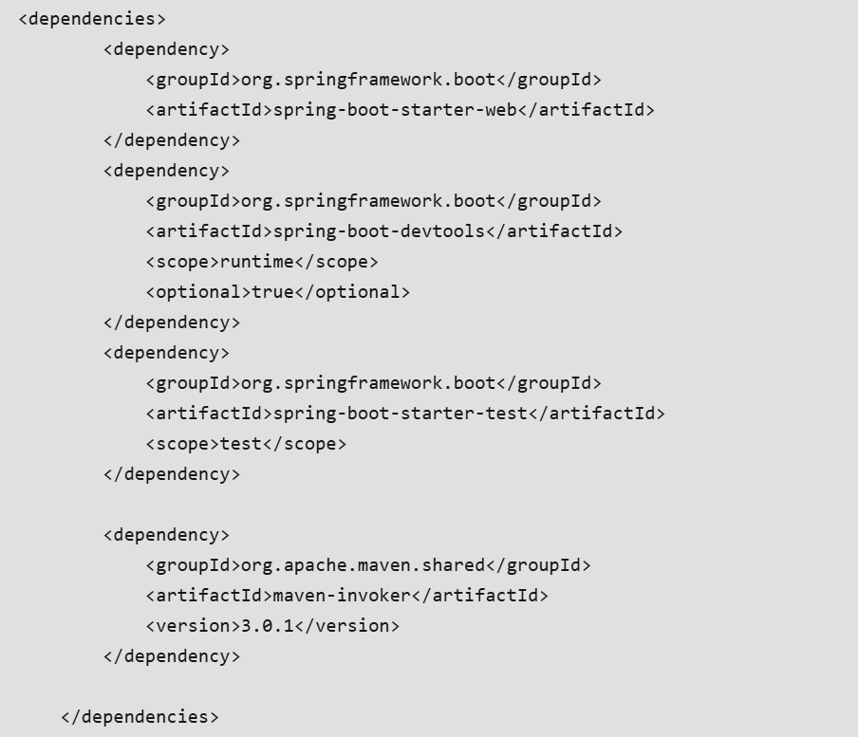

**Project Folder Structure:**

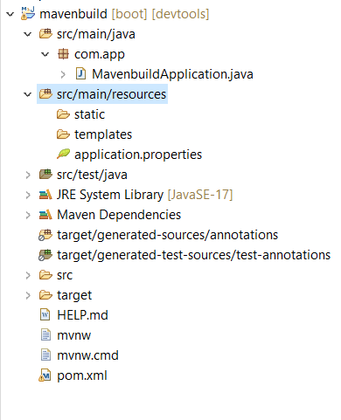

**Step 2: Update Project Configuration (pom.xml)**

Once the project created successfully, then update **pom.xml**file. Below we provide the example pom.xml file.

Here we take a external dependency,

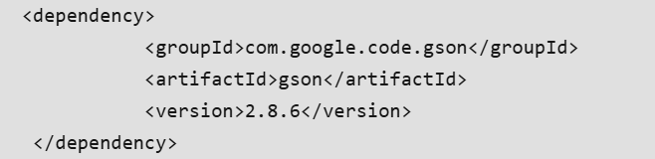

**pom.xml:**

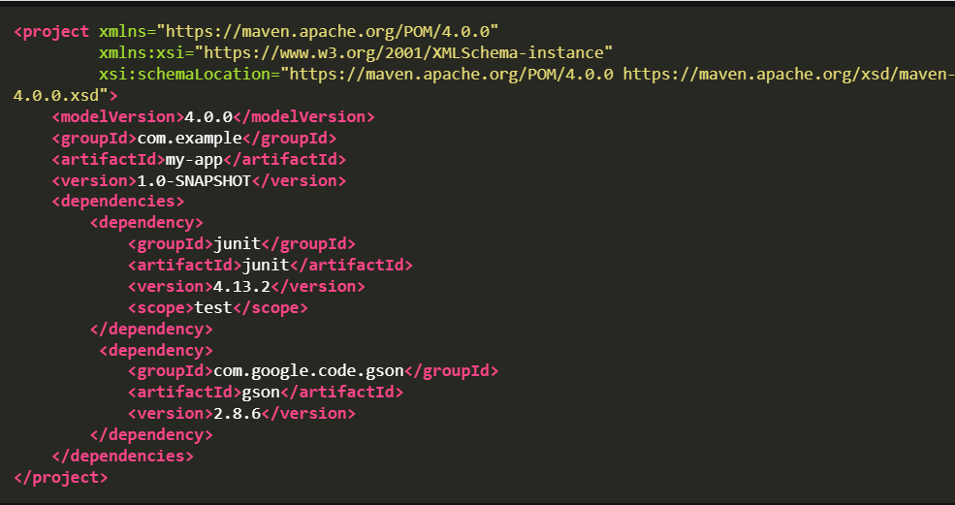

**Step 3: Run Maven Build Process**

Now update the project, after this, start the maven build process by running the maven project.

Use below maven command:

**mvn clean install**

**Output:**

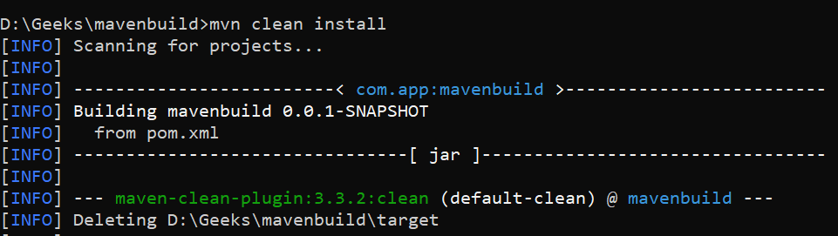

**Maven Build Successfully,**

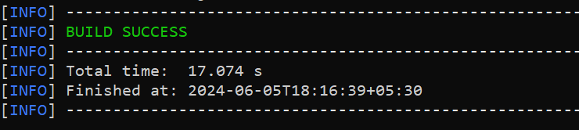

**Step 4: Verify Project Execution**

Once project is successfully running, then this project run on port number on 8080 with tomcat server by default.

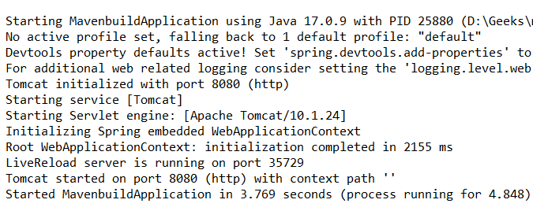

**==================================================================================**

* 1. **Maven - Optional Dependencies:**

Optional dependencies in Maven are used when it is difficult to break up a project into sub-modules (for whatever reason). The idea is that some dependencies are only required for specific aspects of the project and will be removed if such features are not used. Ideally, such a feature would be separated into a sub-module that is dependent on the main functionality project. The only dependencies in this new subproject would be non-optional as using the subproject's functionality requires you to have all of them.

The project cannot be split up (for whatever reason), and these dependencies are marked optional. If a user wants to access the functionality associated with an optional dependency, they must redeclare the dependency in their project.

**Apply <optional> to Dependencies**

You can't separate the producer project into submodules, you can apply <optional> to dependencies that enable additional behavior, as seen in the POM file below.

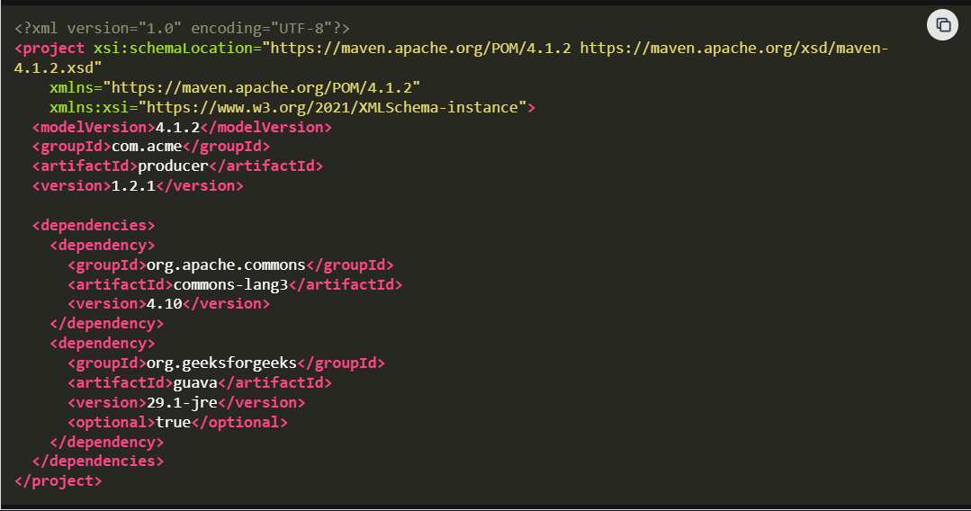

**Why use Optional Dependencies?**

Optional dependencies save both space and memory. They prohibit problematic jars that violate a licensing agreement or create classpath difficulties from being packed into a WAR, EAR, fat jar, or similar format.

**Use of the optional tag**

To make a dependence optional, put the <optional> element to true in the declaration:

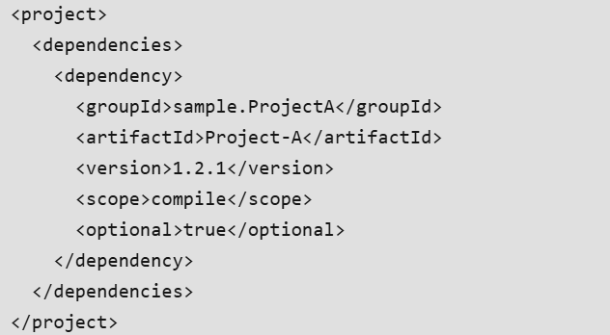

**Create a project for Optional Dependency**

To see the effect of the <optional> tag, create a project that depends on project-with-optional.

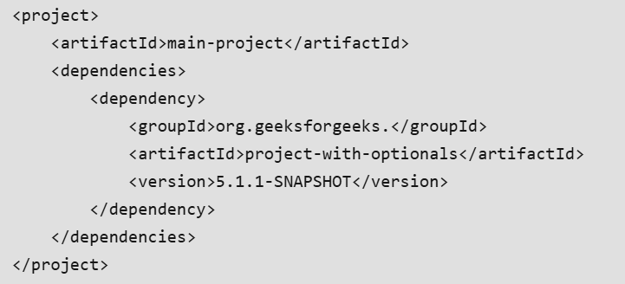

* Now, when we try to reference an optional project from within the project, we discover that it does not exist. The <optional> tag precludes transitive inclusion.
* If we discover that we require an optional project in our main project, we simply designate it as a dependency.

===================================================================================

* 1. **Maven – Exclude a Dependency:**

**Excluding a dependency in a Maven plugin** can be necessary to manage dependencies effectively and prevent conflicts or redundancies in the project.

**Prerequisites:**

* Java Development Kit
* Maven Installation
* Integrated Development Environment

**Tools and Technologies:**

* Maven Repository
* POM File
* Maven Plugins
* Maven Archetypes
* Build Life cycle

**Implementation to Exclude a Dependency in a Maven Plugin:**

In Maven, you might want to exclude a transitive dependency included via a plugin to avoid version conflicts or redundant libraries. This can be done using the <**exclusions**> tag in the POM file.

Let's assume you have a Maven project that uses the maven-compiler-plugin, and you want to exclude a specific dependency commons-logging that is pulled in transitively by another library.

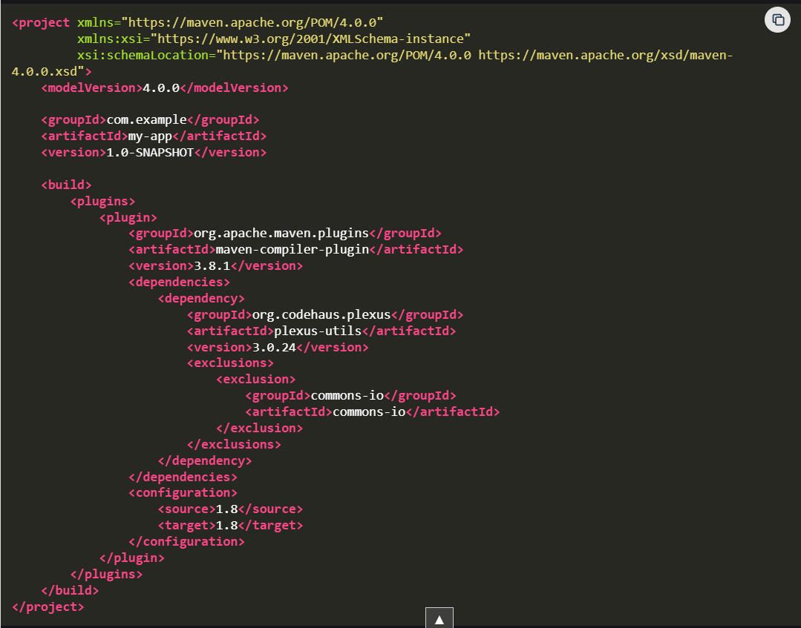\

* The maven-compiler-plugin is configured to compile the source code.
* A specific version of the plexus-utils dependency is included.
* The commons-io transitive dependency is excluded to avoid conflicts.

******************************************************************************************************************************************************************************************************************************************************************************************

**Section 6: Maven Plugins:**

* 1. **Maven Plugins:**

**Maven plugins** are essential components in the Apache Maven build system, designed to extend its functionality. They perform tasks such as compilation, testing, packaging, deployment, and others.

Maven plugins are divided into two main types:

1. Build Plugins
2. Reporting Plugins

**1. Build Plugins**

These plugins are executed during the build process, and they are defined in the **<build>**section in the**pom.xml**file**.**For example, the Compiler Plugin, Surefire Plugin, and Assembly Plugin.

**Common Build Plugins:**

* **Compiler Plugin**: Compiles Java source code into bytecode.
* **Surefire Plugin**: Runs unit tests using frameworks like JUnit or TestNG.
* **Failsafe Plugin**: Executes integration tests, typically for verifying larger system components.
* **JAR Plugin**: Packages compiled code into a JAR (Java Archive) file.
* **WAR Plugin**: Creates a WAR (Web Archive) file for web applications.
* **Assembly Plugin**: Builds custom distributions, such as ZIP files containing project artifacts.
* **Spring Boot Maven Plugin**: Packages Spring Boot applications into executable JARs or WARs.

**2. Reporting Plugins**

These plugins are used for generating reports about the project. These are defined in the **<**reporting**>**section in the **pom.xml**file. Examples include the Surefire Report Plugin for generating test reports and the Javadoc Plugin for generating API documentation.

**Examples**

Here, we created a sample Maven project with the required project dependencies using the Spring Tool Suite IDE.

**Example 1: Build Plugins**

Here we created a Maven project with basic dependencies. Below we provide the pom file for your reference.

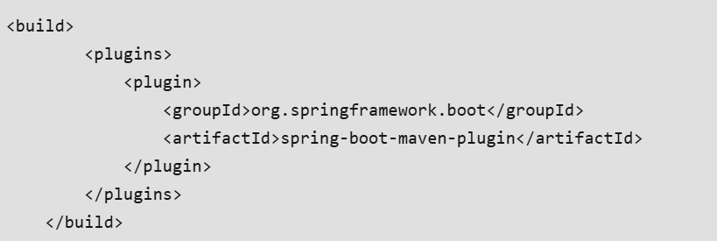

**Example 2: Reporting Plugins**

And here, we use java doc reporting plugin for generating project report.

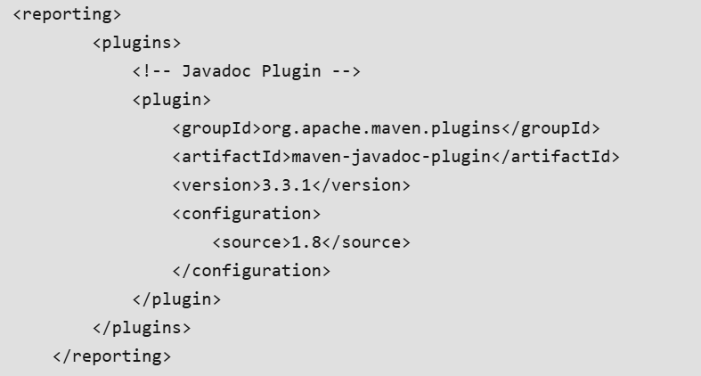

Redirect to maven project by using command prompt after this run below command,

**mvn javadoc:javadoc**

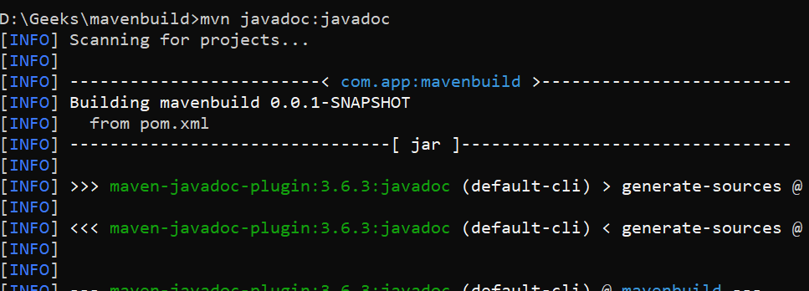

===================================================================================

* 1. **Compiler Plugins:**

The **Maven Compiler Plugin** helps you to compile Java source code. This plugin compiles your project's sources. Since version 3.0, the default compiler is javax.tools.JavaCompiler, which compiles Java sources. The compile goal is associated with the compile phase and is used to compile the primary source files. The test-compile goal is associated with the test-compile phase and compiles the test source files.

**Example of Maven Compiler Plugin Dependency:**

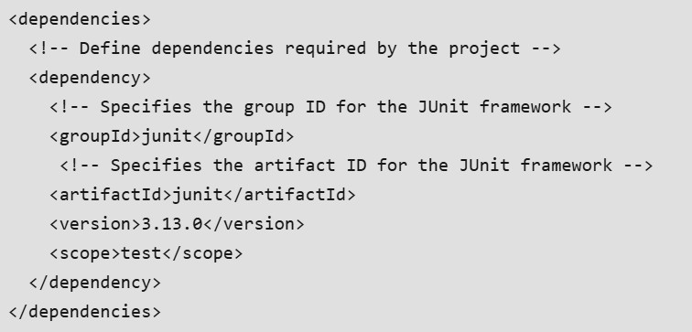

**Troubleshooting of Maven compiler plugin:**

* **By checking the Java version:**Make sure the Java version you're using is compatible with the source version. Please ensure that you have the right Java version.
* **By verifying the Maven version**: Ensure that you are using the most recent and updated version of Maven.
* **By checking Maven Plugins:** Ensure that all needed plugins are installed. They must be included in the '.xml' file for your project.

**Key configuration elements of the Maven Compiler Plugin**

* **<target>:**Describes which Java version of the resulting bytecode should be utilized. for instance, Take \target>1.9</target>.
* **<source>:**Indicates the Java version of the source code that should be utilized. for instance, Take \source>1.9</source>.
* **<fork>:** Indicates if the compiler should run in a different process. As an example, take <fork>true</fork>
* **<encoding>:** Configures the source files' character encoding.
* **<compilerVersion>:** It indicates the compiler version to be used.

**Configuration of the Maven compiler plugin:**

**Step 1: Create Compiler Plugin**

Unlike many other plugins, the Compiler Plugin executes automatically during its phases, therefore you do not need to specify executions. However, you must mention the version of the Compiler Plugin.

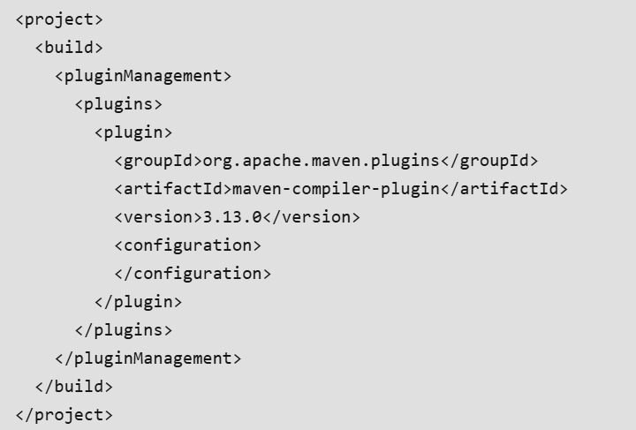

**Step 2: Set the Java version**

We can make the Java version one of the POM's properties for convenience.

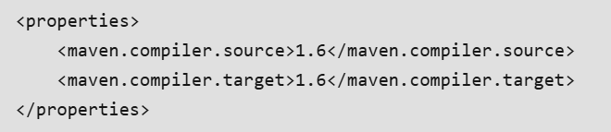

**Step 3: Compile Sources Using A Different JDK**

The compiler version parameter allows you to select the version of the compiler that the plugin will use. You must also set the fork option to true to make this function.

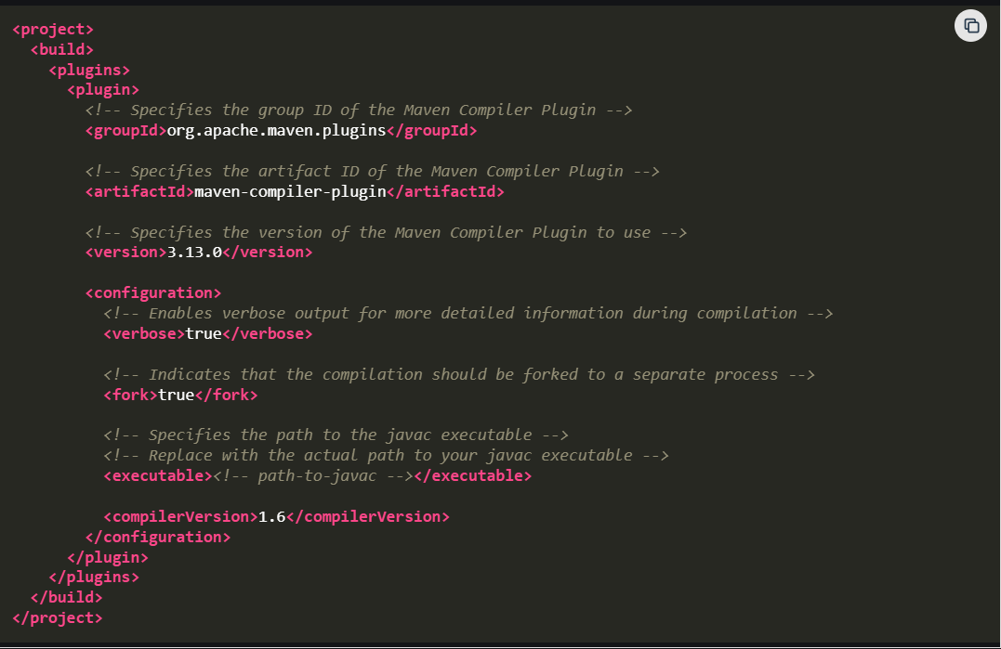

**Step4: Create a class for MavenCompilerPlugin**

Create a MavenCompilerPlugin class that imports a package from another module.

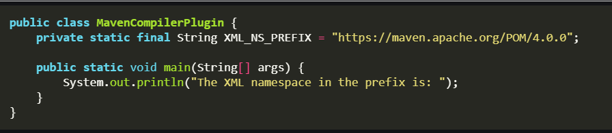

* In the public class, it can be accessed from other classes.
* The main method is static, which means it can be invoked without generating a new class instance.
* It accepts an array of String objects as its parameter, supplying command-line parameters to the application.

===================================================================================

* 1. **Surefire Plugins:**

Maven Surefire is a plugin that runs the unit tests for a Maven application or project. It is used throughout the Maven build lifecycle's testing step. After testing, this plugin creates a unit test report. It can create reports in two formats that are, plain text and XML. The XML format for report production is the default mode. The plain text format has the .txt extension, but the XML format has the .xml extension.

**Implementation of the Maven Surefire Plugin**

**Step 1: Usage of Surefire Plugin**

Maven proposes defining the version of the plugin we wish to use in the pom.xml file.

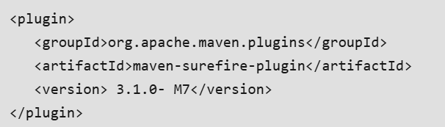

**Step 2: Configuration of Surefire Plugin**

The Surefire plugin is compatible with the JUnit and TestNG test frameworks. Surefire's behavior remains consistent regardless of the framework used.

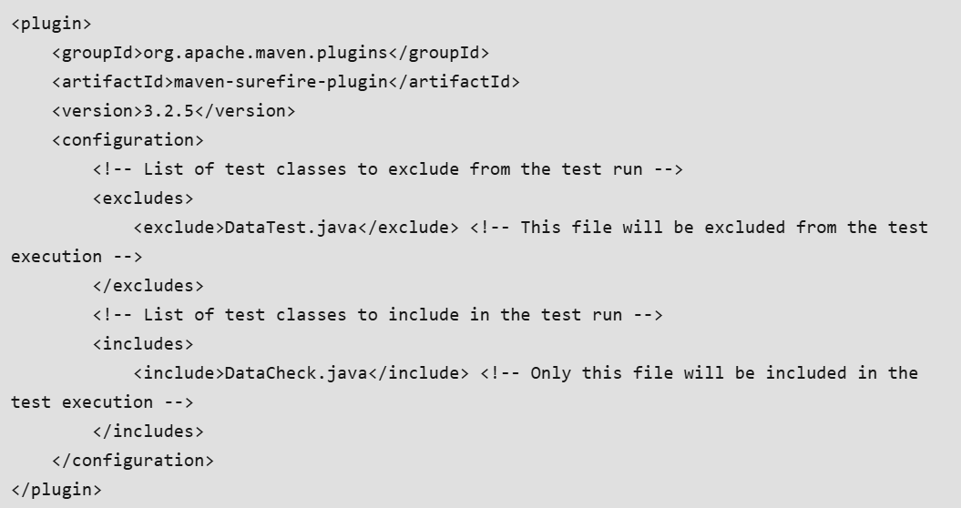

* It is simple to handle such circumstances, use the <includes> and <excludes> arguments to define the plugin.
* The <include> parameter includes all the files named within it for unit testing.
* Similarly, the <exclude> argument excludes files from the testing procedure.

**Step 3: Run a Single Test Case**

You may want to run a specific test class multiple times during the testing phase.

mvn surefire:test -Dtest=TestCircle

******************************************************************************************************************************************************************************************************************************************************************************************

**Section 7: Maven Commands and Options:**

* 1. **Maven Commands and Options:**

Maven commands are used to execute various tasks such as building projects, running tests, and generating reports. Some common commands are described below.

**mvn clean**

mvn clean

The **mvn clean**command in Maven is used to remove the target directory and all the build artifacts contained within it.

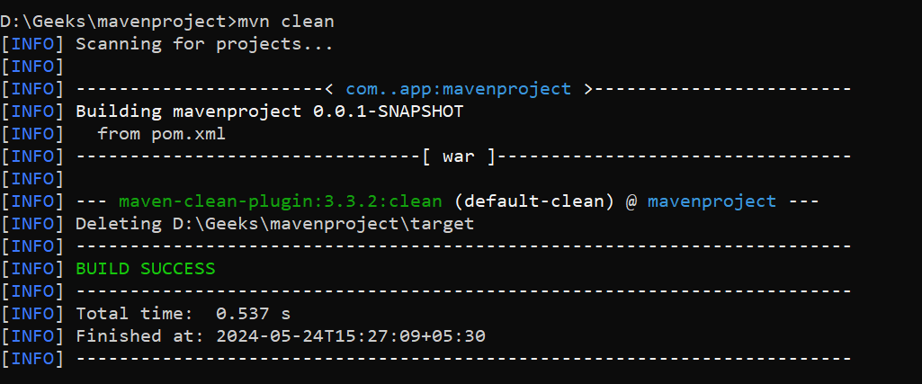

**mvn compiler:compile**

mvn compiler:compile

The **mvn compiler:compile** command in Maven is used to compile the source code of a Maven project. It is part of the Maven Compiler Plugin, which handles the task of compiling Java source files.

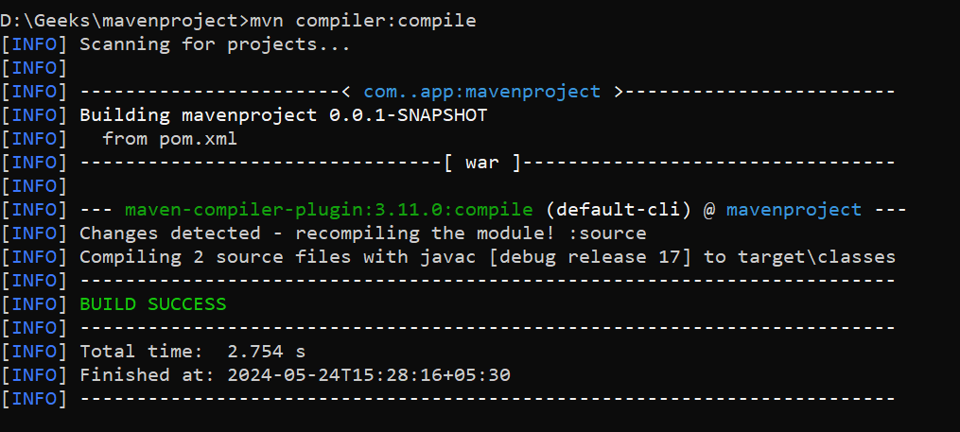

**mvn compiler:testCompile**

mvn compiler:testCompile

The **mvn compiler:testCompile** command in Maven is used to compile the test source code of a Maven project. It is part of the Maven Compiler Plugin, which manages the compilation of both main and test source files.

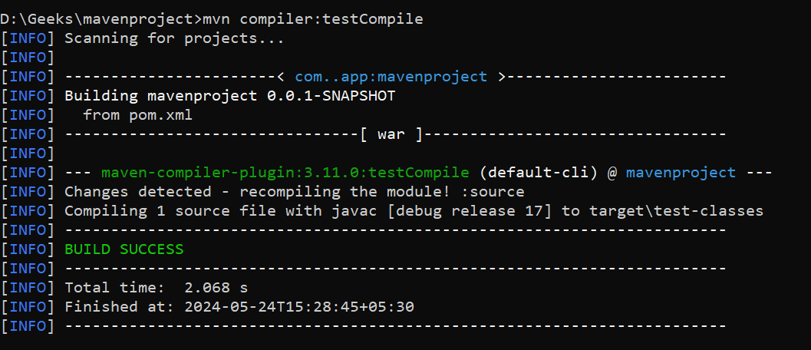

**mvn package**

mvn package

The **mvn package** command in Maven is used to compile the code, run the tests, and package the compiled code and other resources into a distributable format, such as a JAR, WAR, or EAR file. This command is a key part of the Maven build life cycle, typically used to create an artifact that can be deployed or distributed.

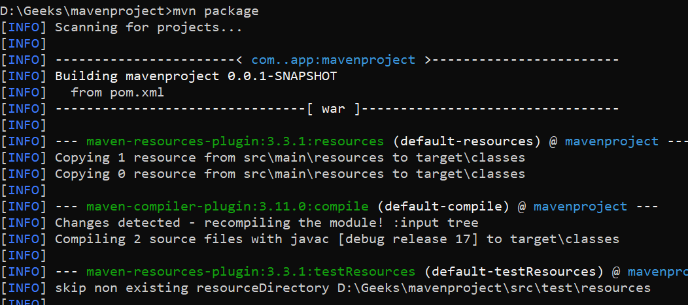

**mvn install**

mvn install

The mvn install command in Maven is used to compile the code, run tests, and package the compiled code and other resources into a JAR, WAR, or other artifact, and then install that artifact into the local Maven repository.

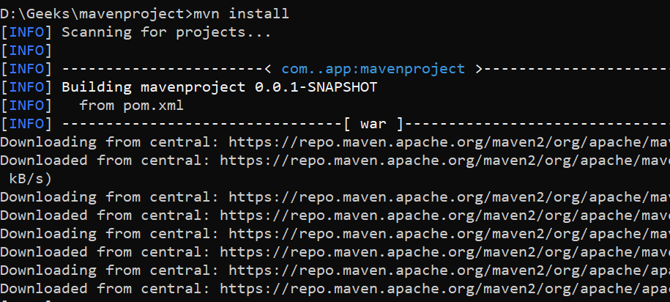**mvn deploy**

mvn deploy

The mvn deploy command in Maven is used to compile the code, run tests, package the artifact, and then deploy the packaged artifact to a remote repository. This remote repository is typically used for sharing the artifact with other developers or systems, and it can be a private repository within an organization or a public repository like Maven Centra.

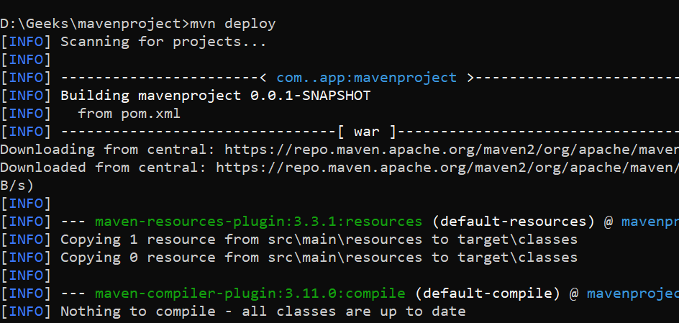

**mvn validate**

mvn validate

The mvn validate command in Maven is used to validate the project structure and configuration. This command checks the project for correctness before starting the build process. It ensures that all necessary information is available and correct before proceeding to subsequent phases of the build life cycle.

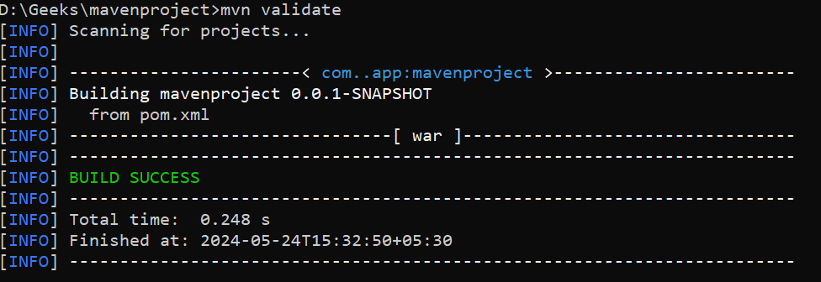

**mvn dependency:tree**

mvn dependency:tree

The mvn dependency:tree command in Maven is used to display the dependency tree for a project. This command is part of the Maven Dependency Plugin, and it provides a visual representation of the project's dependencies, including transitive dependencies, in a tree format.



**mvn dependency:analyze**

mvn dependency:analyze

The **mvn dependency:analyze** command in Maven is used to analyze the dependencies of a project to identify unused declared dependencies and detect used but undeclared dependencies. This command is part of the Maven Dependency Plugin, and it helps ensure that your pom.xml file accurately reflects the actual dependencies of your project.

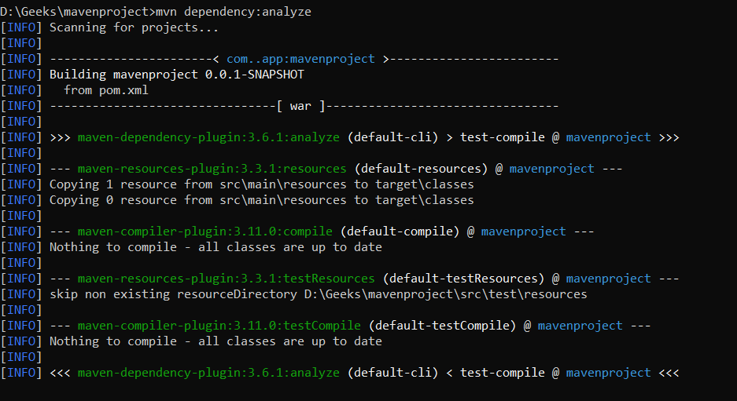

**mvn archetype:generate**

mvn archetype:generate

The **mvn archetype:generate** command in maven is used for generating a new Maven project from an existing project template that is called an archetype.

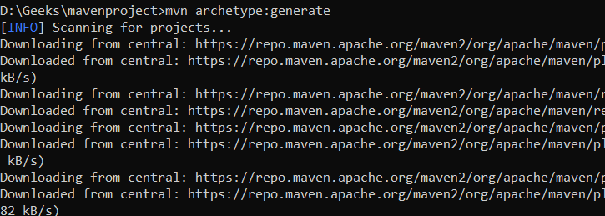

**mvn site:site**

mvn site:site

The **mvn site:site** command in Maven generates the project's site documentation. This command is part of the Maven Site Plugin, which is used to generate a website or documentation for your project.

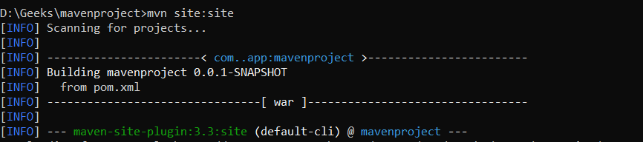

**mvn test**

mvn test

The **mvn test** command in Maven is used to execute the tests in a Maven project. When you run mvn test, Maven will compile the project's source code and then execute the test cases present in the project using a testing framework like JUnit or TestNG.

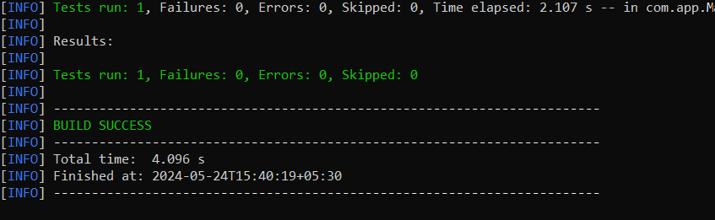

**mvn compile**

mvn compile

The mvn compile command in Maven is used to compile the source code of a Maven project. When you run mvn compile, Maven compiles the Java source files located in the src/main/java directory of your project.

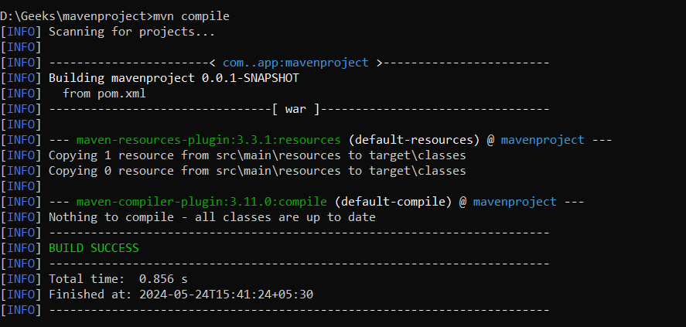

**mvn verify**

mvn verify

The **mvn verify** command in Maven is used to run any checks on the results of integration tests to ensure quality criteria are met. This command is invoked in the integration test phase and is typically used to perform additional checks on the project after the integration tests have been executed.

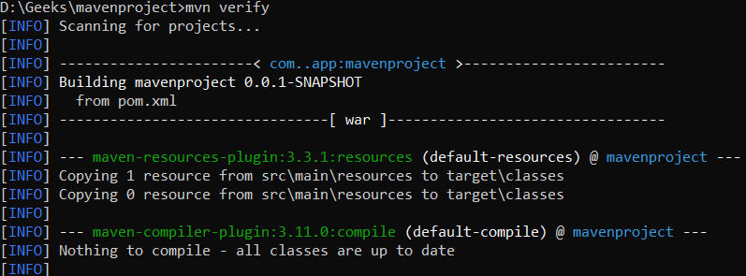

**Maven Options**

Maven options are command-line parameters that modify the behavior of Maven commands. They provide flexibility for tasks such as skipping tests, activating profiles, setting system properties, and enabling debug logging, ensuring tailored builds to meet specific requirements. Below are some Maven command-line options.

**mvn -help**

mvn -help

The mvn -help command in Maven is used to display basic usage information and options available for the Maven command-line interface. It provides a summary of commonly used Maven commands and options.

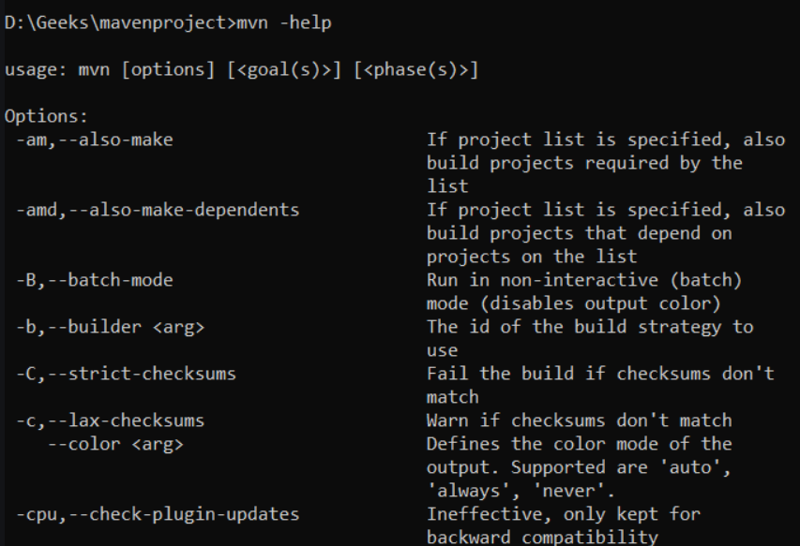

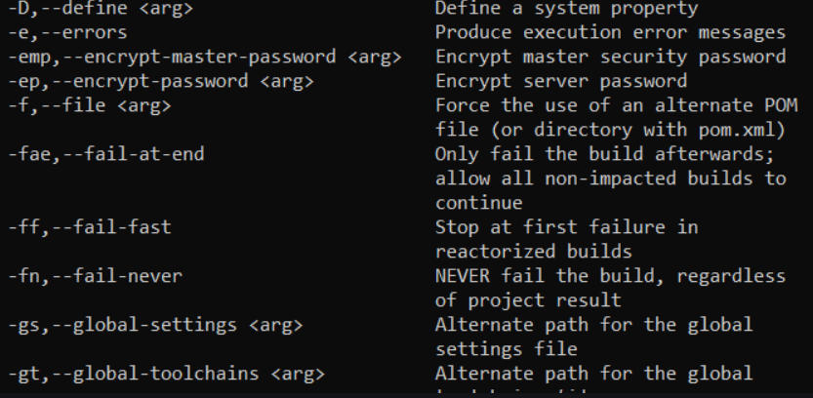

**mvn -X package**

mvn -X package

The command mvn -X package invokes Maven in debug mode (-X) and executes the package goal.

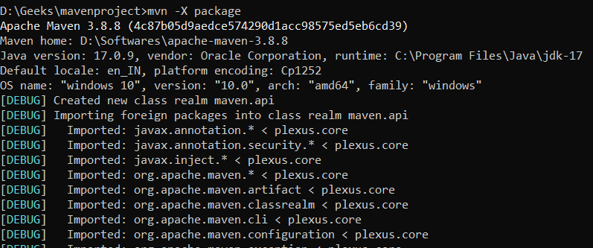

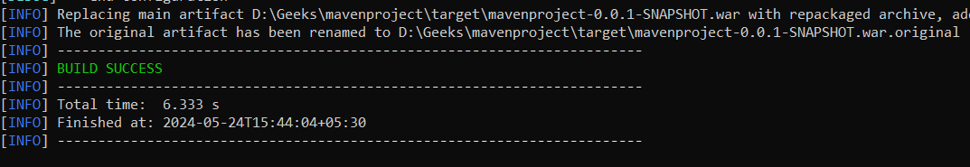

**mvn -v**

mvn -v

The **mvn -v** command in Maven is used to display version information about Maven itself, including the Maven version, Java version, and operating system information.

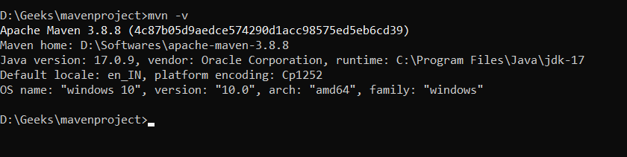

**mvn -T 4 clean install**

mvn -T 4 clean install

The command **mvn -T 4 clean install** is used to build a Maven project with multi-threading enabled. Specifically, -T 4 instructs Maven to use four threads for the build process.

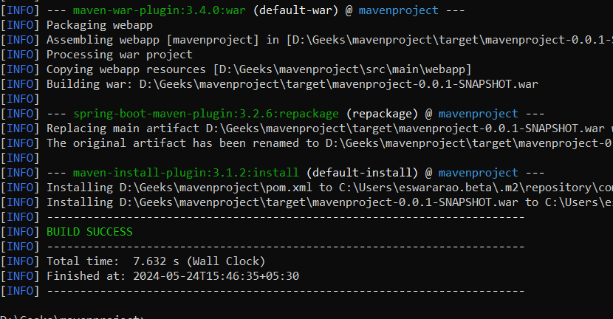

===================================================================================

* 1. **Maven Commands and Options:**

**The Maven Wrapper (mvnw)** is a utility that allows you to run Maven projects without needing a pre-installed Maven version. It ensures that the correct Maven version is used, providing consistency across different development environments.

**What is Maven Wrapper?**

The Maven Wrapper is a script (mvnw or mvnw.cmd) that can be added to a project. It allows you to run Maven commands using a specified Maven version, ensuring that all developers working on the project use the same Maven version and avoiding potential compatibility issues.

**Why Use Maven Wrapper?**

* **Consistency**: It ensures all the developers use the same Maven Version.
* **Ease of use**: No need to install the Maven on every developer's machine.
* **Portability**: Makes it easier to setup the CI/CD pipelines as the exact Maven version is specified of the application

**Components of Maven Wrapper**

* **mvnw and mvnw.cmd**: These are shell scripts to run the maven commands.
* **.mvn/wrapper/maven-wrapper.jar**: The java archive that downloads and installs the specified maven version.
* **.mvn/wrapper/maven-wrapper.properties**: Its configuration file specifying the maven version.

**Step by step Implementation of Maven Wrapper:**

Step 1: Create a Maven Project

Create a Maven project using the following command:

mvn archetype:generate -DgroupId=com.example -DartifactId=my-app -DarchetypeArtifactId=maven-archetype-quickstart -DinteractiveMode=false

cd my-app

**Output:**

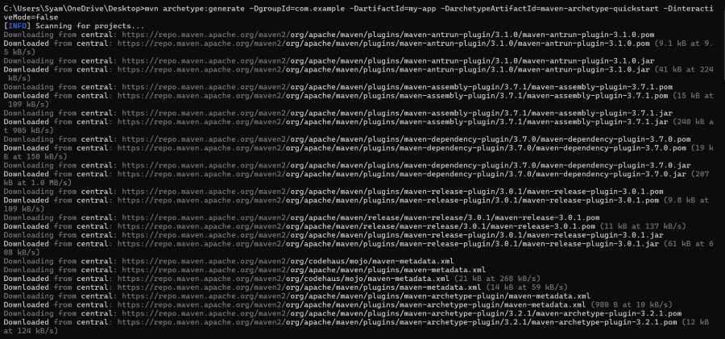

**Step 2: Add the Maven Wrapper to your project**

**Navigate to the project directory and install the Maven Wrapper using the following command:**

mvn -N io.takari:maven:wrapper

**Output:**

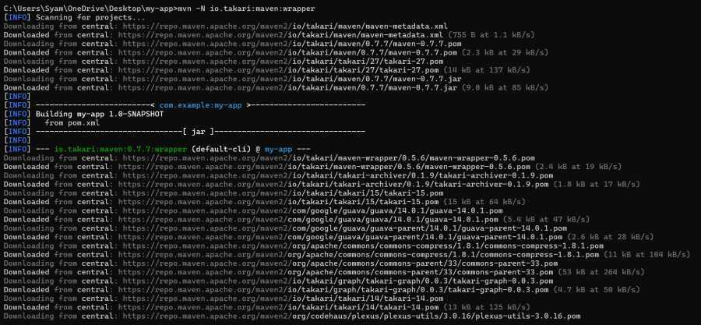

**Build Result:**

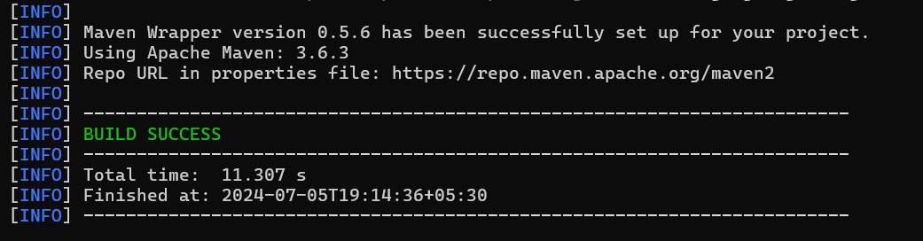

This command generates several files necessary for the Maven Wrapper.

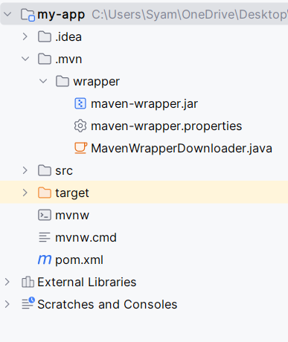

**Step 3: Use Maven Wrapper to Run Maven Commands**

Instead of mvn clean install, use the wrapper scripts in your application:

./mvnw clean install

This command ensures that the build uses the Maven version specified in maven-wrapper.properties.

**Output:**

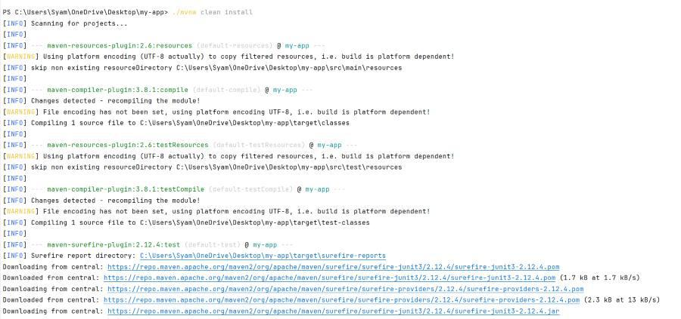

**Installation Result:**

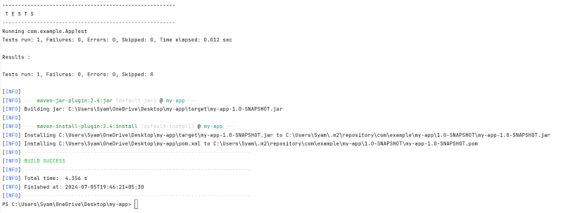

By using Maven Wrapper, we can avoid issues related to the different Maven versions and make it easier for new developers to get started with the project. This article provides the comprehensive overview of the Maven Wrapper, including how to set it, up, configure the dependencies and plugins and run the Maven commands.

===================================================================================

* 1. **Skipping Tests with Maven:**

Skipping tests during the Maven build process is a common requirement, especially in scenarios where tests are time-consuming or not applicable to the current build phase**.**Skipping tests in Maven can be achieved in several ways depending on the requirements.

**Different Ways to Skip Tests with Maven**

We can skip tests in Maven by using below-mentioned ways.

* Using the Command line
* Configuring the **pom.xml** File
* Using Profiles

**Tools and Technologies**

* Java Programming
* Java Version 17
* Maven 3.X.X
* JUnit
* Spring Tool Suite
* Command Prompt

**Steps to Skip Tests with Maven:**

Here, we created a simple maven project by using spring initializr with required maven dependencies and we mention them in the below.

**Step 1: Create a Maven Project**

Create a Maven project by using Spring Tool Suite with basic dependencies.

Dependencies:

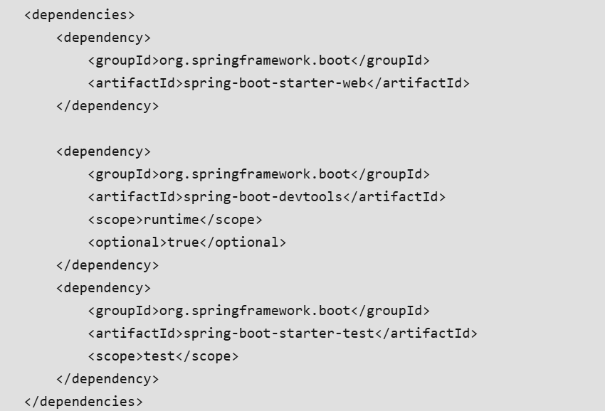

**Step 2: Project Structure**

Once project created successfully, now observe the project folder structure.

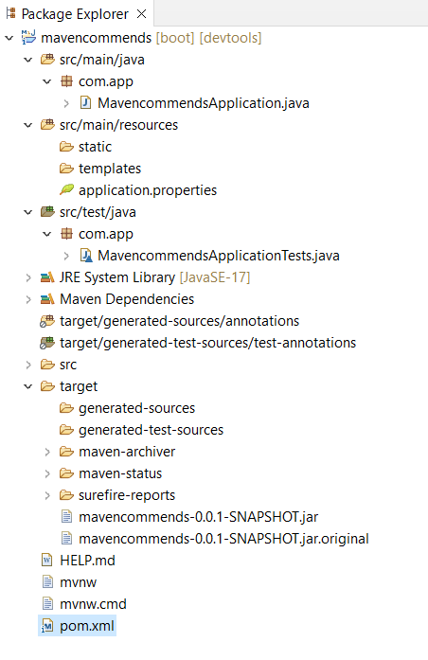  
**Step 3: pom.xml Configuration**

Open the pom.xml file which contains project configuration. This file contains information like project configuration, dependency management and other project related information.

**Step 4: Skipping Tests Using Command Line**

First, we skip tests in Maven by using maven commands. To do this, open command prompt, then redirect to created maven project by using **cd** command.

Once redirect into project by using commands. Now run the below command to skip tests in the maven project. We can skip tests by adding a -D property to the Maven.

**mvn install -Dmaven.test.skip=true**

**or,**

**mvn install -DskipTests**

**Output:**

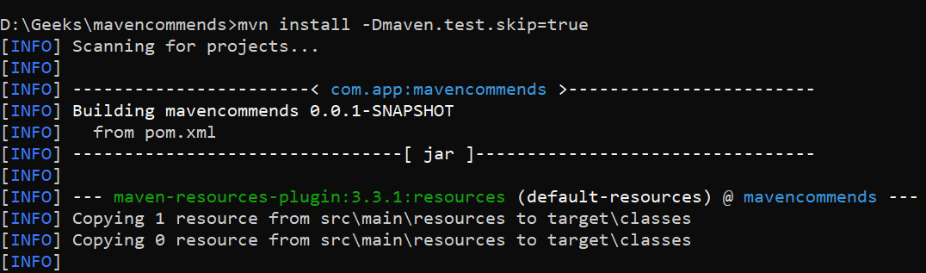

Tests skipped:



Maven Build Successfully:

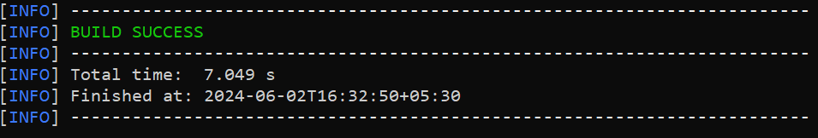

**Step 5: Configure the pom.xml file for Test Skipping**

This is another way to skips the tests in the maven project. For this we need add a property in the **pom.xml**file.

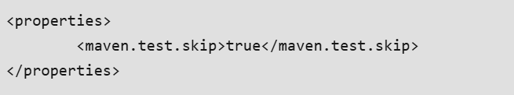

Now, run this project as JUnit. After running successfully, open the JUnit panel. Before adding this property we can see some information in the JUnit Panel. After adding we skip the tests that's why no JUnit information is available.

**Output:**

Before adding test skip property:

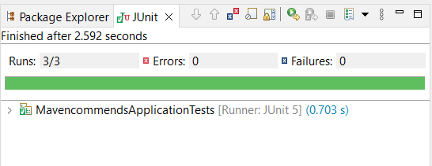

After adding test skip property:

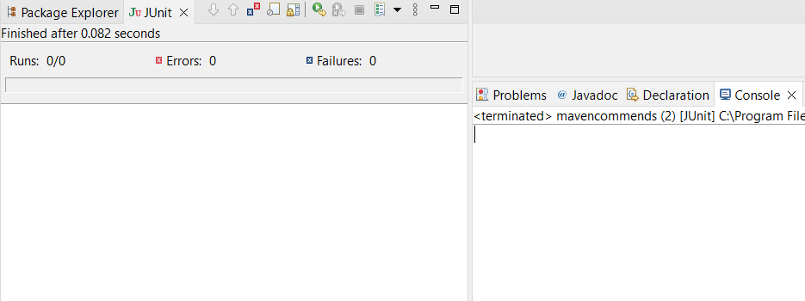

**Step 6: Using Profiles**

We can define a Maven profile to skip tests and activate this profile when needed. This method allows more flexibility as we can choose when to skip tests by activating the profile.

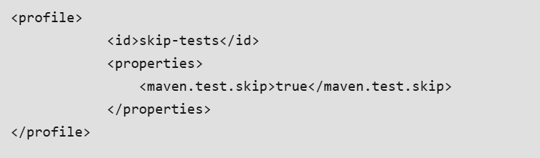

Add this profile in the **pom.xml**file and run the project then we get expected output.

**Output:**

Before adding test skip property:



After adding test skip property:



===================================================================================

* 1. **Difference Between “mvn verify” and “mvn test”:**

**mvn verify**

The mvn verify command in Maven is used to execute the verify phase, which occurs later in the build lifecycle than the test phase. This command runs not only unit tests but also any integration tests, and it checks to ensure that the package is valid and meets quality requirements.

**Working of mvn verify:**

* **Compiles the code:** It compiles the source code.
* **Compiles the tests:** It compiles the test source code.
* **Runs the tests:** It runs the unit tests.
* **Additional checks:** It performs any checks defined in the lifecycle, such as integration tests and any other checks defined by the project’s configuration.

**yntax:**

**mvn verify**

**mvn test:**

The mvn test command runs in the test phase of the Maven build lifecycle. This phase is designed specifically to execute the unit tests that are present in the project.

**Working of mvn test:**

* **Compiles the code:** Maven compiles the main source code.
* **Compiles the tests:** Maven compiles the test source code.
* **Runs the tests:** Maven runs the tests using a test framework such as JUnit or TestNG.

**Syntax:**

**mvn test**

**Tools And Technologies are used:**

* Java programming
* Maven
* Spring Tool Suite
* Commend Prompt

**Implementation of mvn verify and mvn test:**

**Step 1: Create a Maven Project**

Create a Maven project using any IDE, such as Spring Tool Suite, and include essential Maven dependencies in the pom.xml file.

**Dependencies:**

Below commends are available in **pom.xml** file once project is successfully created.

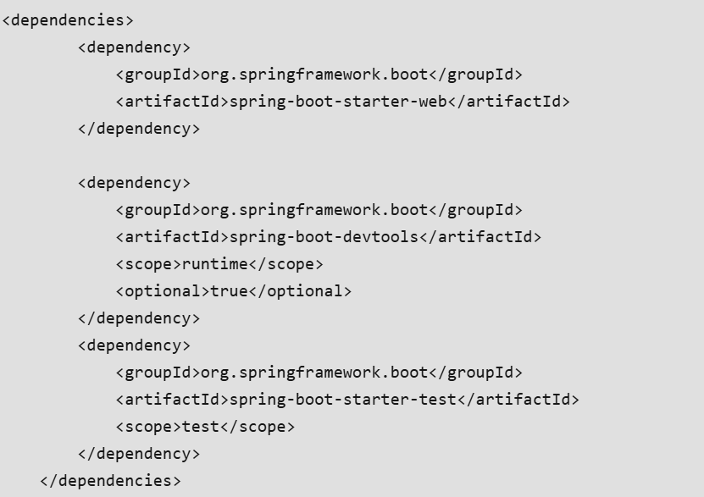

**Project Folder Structure:**

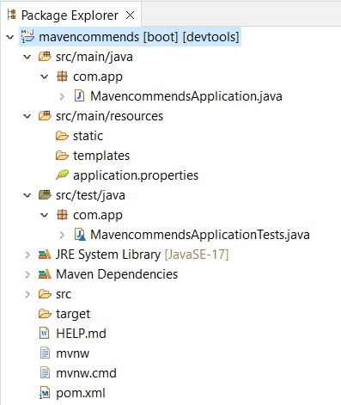

**Step 2: Write Sample Java Code**

Now, write a sample Java code in the test class to execute unit tests.

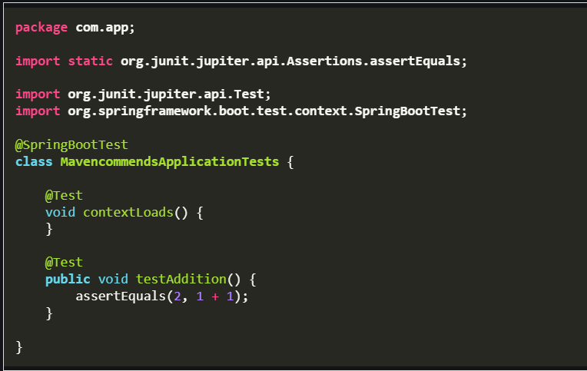

**Step 3: Navigate to Project Folder**

Now, open the command prompt, then redirect into project folder by using **cd**command.

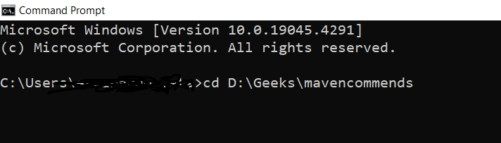

**Step 4: Execute mvn verify Command**

Now, type the **mvn verify**command and click on enter then you will get below result.

**Output:**

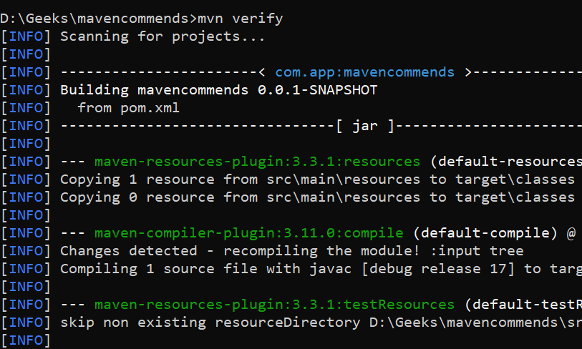

Maven Build Successfully:

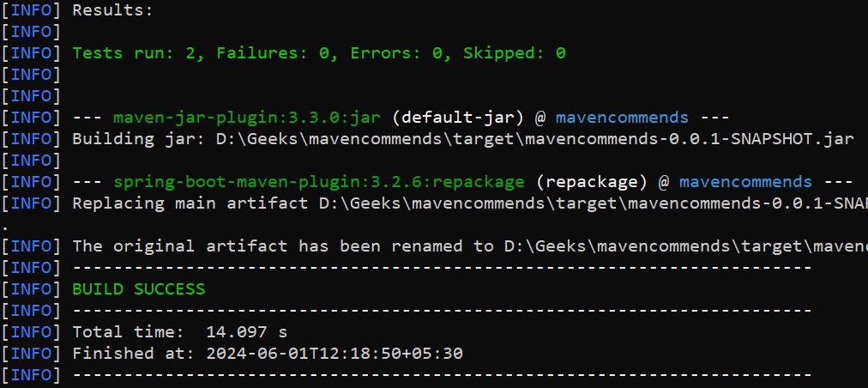

**Step 5: Run mvn test Command**

**Now, check the mvn test commend to execute unit tests during the test phase.**

**Output:**

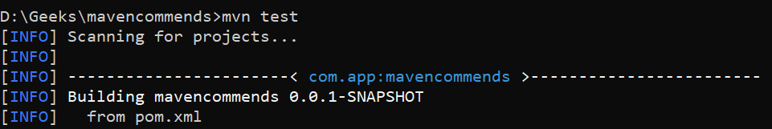

**Maven Build Successfully:**

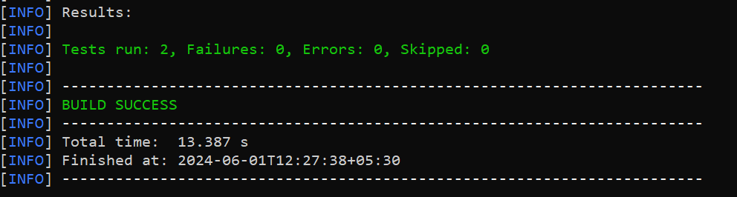

**Difference Between mvn verify and mvn test:**

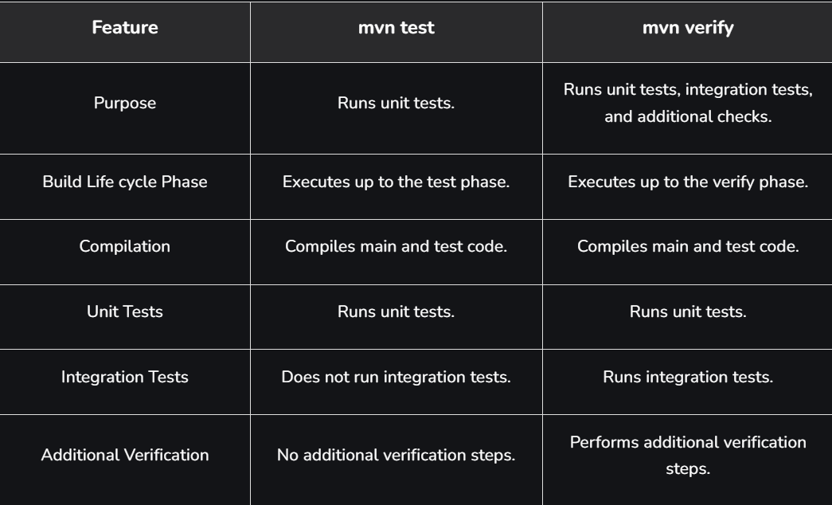 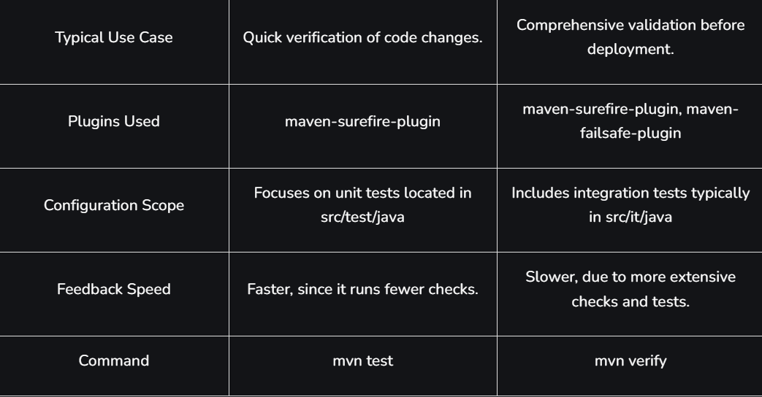

**\*\*\*\*\*\*\*\*\*\*\*\*\*\*\*\*\*\*\*\*\*\*\*\*\*\*\*\*\*\*\*\*\*\*\*\*\*\*\*\*\*\*\*\*\*\*\*\*\*\*\*\*\*\*\*\*\*\*\*\*\*\*\*\*\*\*\*\*\*\*\*\*\*\*\*\*\*\*\*\*\*\*\*\*\*\*\*\*\*\*\*\*\*\*\*\*\*\*\*\*\*\*\*\*\*\*\*\*\*\*\*\*\*\*\*\*\*\*\*\*\*\*\*\*\*\*\*\*\*\*\*\*\*\*\*\*\*\*\*\*\*\*\*\*\*\*\*\*\*\*\*\*\*\*\*\*\*\*\*\*\*\*\*\*\*\*\*\*\*\*\*\*\*\*\*\*\*\*\*\*\*\*\*\*\*\*\*\*\*\*\*\*\*\*\*\*\*\*\*\*\*\*\*\*\*\*\*\*\*\*\*\*\*\*\*\*\*\*\*\*\*\*\*\*\*\*\*\*\*\*\*\*\*\*\*\*\*\*\*\*\*\*\*\*\*\*\*\*\*\*\*\*\*\*\*\*\*\*\*\*\*\*\*\*\*\*\*\*\*\*\*\*\*\*\*\*\*\*\*\*\*\***

**Section 8: Maven and Junit:**

* 1. **JUnit – Executing Tests with Maven Build:**

[JUnit](https://www.geeksforgeeks.org/software-testing/introduction-to-junit-5/) is a widely-used testing framework for Java that allows developers to create and execute unit tests. When combined with [Maven](https://www.geeksforgeeks.org/devops/apache-maven/), the build automation tool, it becomes easy to automate the execution of these tests as part of the build lifecycle. In this article, we will explore **how JUnit works with Maven**, how to set up the project, and how to run the tests efficiently.

**Understanding Maven and JUnit Integration**

**Maven**

Maven is a build automation and project management tool that simplifies managing project dependencies, building, testing, and packaging applications. It uses the Project Object Model (POM) file to define project structure, dependencies, and build configurations.

**JUnit**

JUnit is a Java testing framework used for testing individual units of source code. It allows developers to write test cases for methods and functionalities in isolation and verify that they produce the expected outcomes.

**Maven and JUnit Integration**

Maven integrates with JUnit through the Maven Surefire Plugin, responsible for running unit tests during the build process. When you run a Maven build, the Surefire Plugin automatically detects and runs test cases located in the src/test/java directory. These test cases are typically written using JUnit.

Maven follows a build lifecycle, where each lifecycle phase performs a specific task. The **test** phase is the step in the lifecycle where Maven runs the JUnit tests.

**Lifecycle Phases in Maven:**

* **compile**: Compiles the source code.
* **test**: Runs unit tests using the Surefire Plugin and JUnit.
* **package**: Packages the compiled code into a JAR or WAR file.
* **install**: Installs the built package into the local Maven repository.

**JUnit Testing with Maven:**

This example project demonstrates how to set up JUnit tests with Maven. The project includes a simple Java class (Calculator) with methods to add and subtract numbers, along with the corresponding JUnit test class (CalculatorTest) to validate these methods.

**Step 1: Create a New Maven Project**

Create a new Maven project using IntelliJ IDEA. Choose the following options:

* **Name**: JUnitMavenExample
* **Build system**: Maven
* Click on the **Create** button.

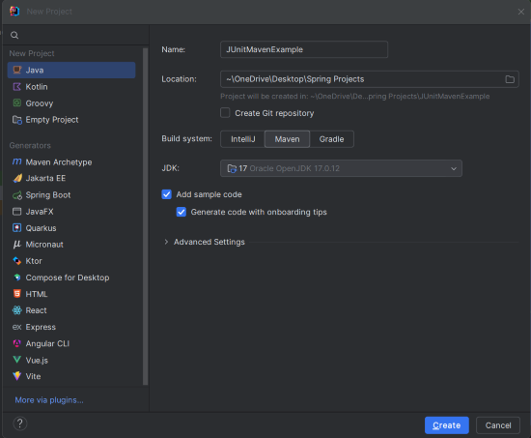

**Project Structure**

After the project creation done successfully, then the folder structure will look like the below image:

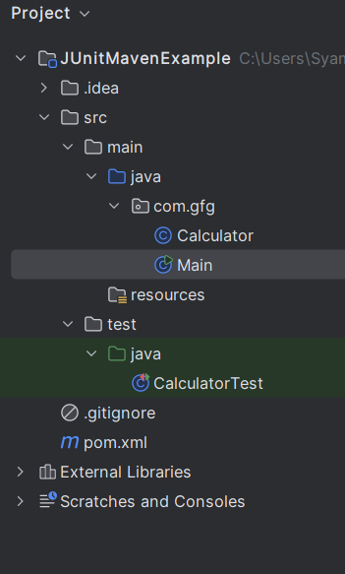

**Step 2: Add Dependencies to pom.xml**

Open the pom.xml file and add the JUnit dependency, which is necessary for running the JUnit tests.

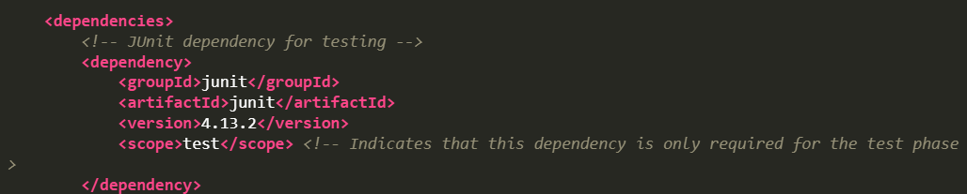

The JUnit dependency is included with the **test** scope, meaning it's only used during the test phase. The maven-surefire-plugin ensures the tests are executed during the build process.

**Step 3: Create the Calculator Class**

Create the Calculator class, which will have basic arithmetic methods: add() and subtract().

**Calculator.java**

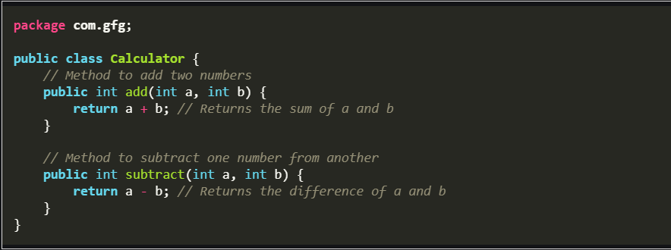

* **add(int a, int b)**: This method adds the two numbers and returns the result.
* **subtract(int a, int b)**: This method subtracts the second number from the first number.

**Step 4: Create the Main Class**

Create the Main class to perform the basic arithmetic operations and demonstrate the use of the Calculator class.

Main.java

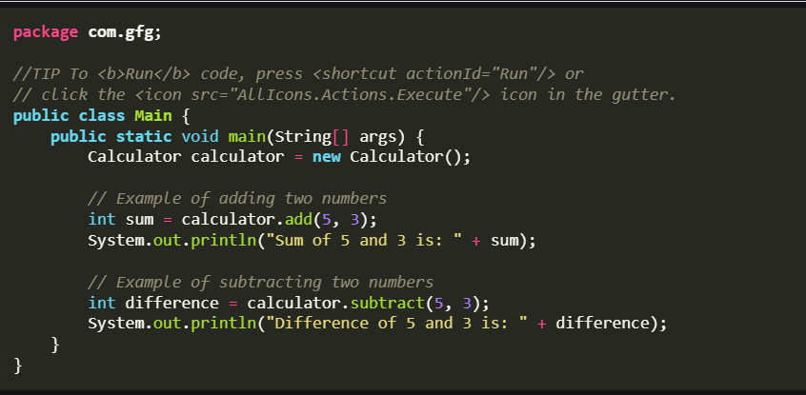

The main method allows for the standalone execution of the class. It demonstrates the use of the add and subtract methods by creating an instance of the Calculator class and printing the results to the console.

**Step 5: Create the JUnit Test Class**

Create the CalculatorTest class containing test methods to verify the functionality of the Calculator class.

**CalculatorTest.java**

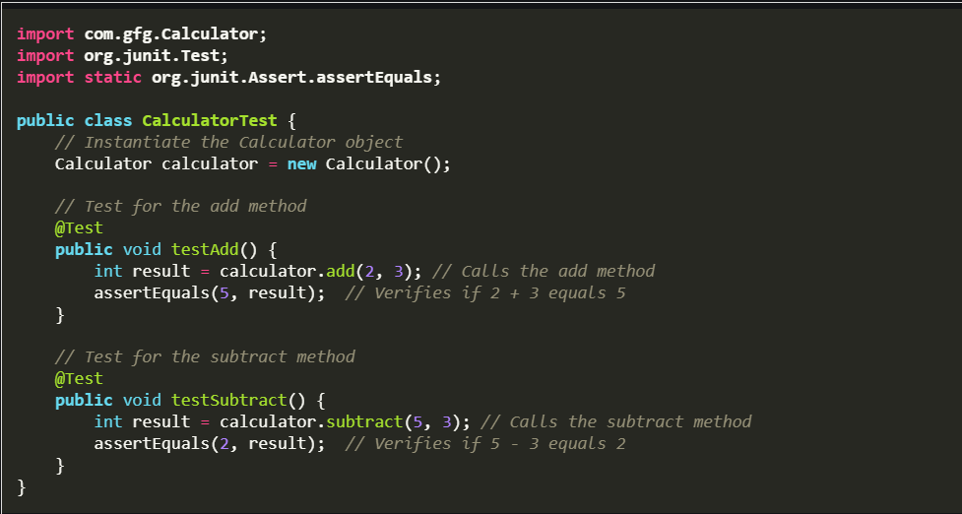

* **testAdd()**: Checks if the add() method of the Calculator returns the correct sum.
* **testSubtract()**: Verifies the output of the subtract() method.
* assertEquals(expected, actual): Asserts that the expected and actual values are the same.

**Step 6: Run the Application**

Once the project is complete, run the Main class, and you should see the following output:

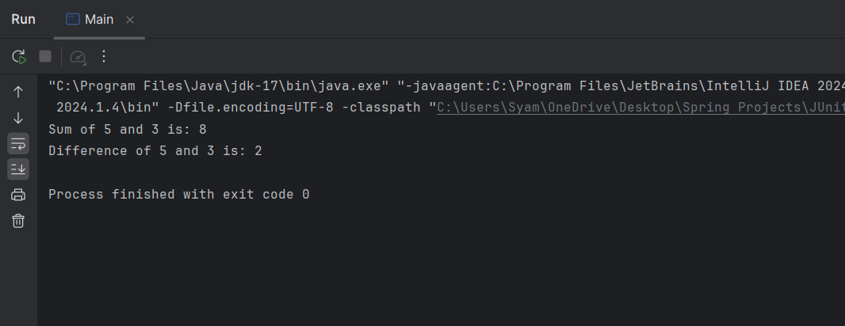

**Step 7: Run the Tests with Maven**

To execute the tests, run the following Maven command in the project directory:

mvn test

This command compiles the code and runs the test cases located in the src/test/java directory.

**Test Results:**

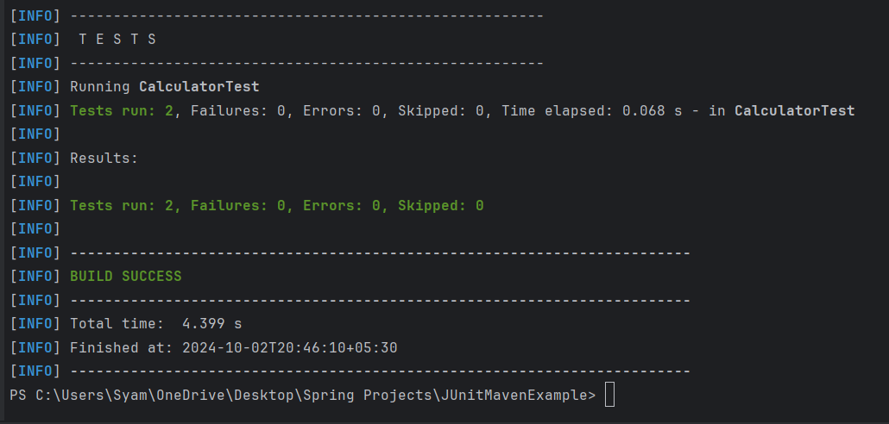

**Step 8: Generated Test Report**

Maven's Surefire Plugin automatically generates a test report in the target/surefire-reports/ directory.

* **Surefire report file**: target/surefire-reports/CalculatorTest.txt  
  This file contains a detailed log of the test execution, including pass/fail status and stack traces for any failed tests.

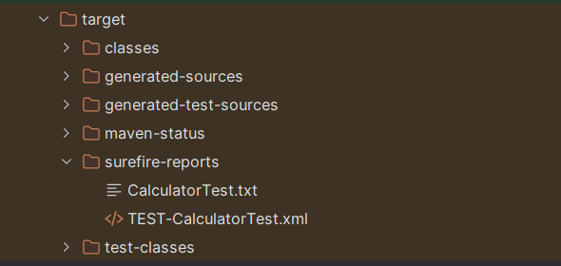

===================================================================================

* 1. **Why Maven Doesn’t Find JUnit Tests to Run?**

When [Maven](https://www.geeksforgeeks.org/devops/apache-maven/) fails to find JUnit tests to run, it can be frustrating and disrupt the development process. Several common issues can cause this problem, ranging from incorrect directory structures, missing dependencies, and to misconfigured plugins. One common issue developers face when using Maven is that it doesn't find and run JUnit tests.

**Understanding Maven and JUnit**

**Maven** uses a **Project Object Model** file, pom.xml, to manage project configurations, dependencies, and plugins. [JUnit](https://www.geeksforgeeks.org/software-testing/introduction-to-junit-5/) is a widely used testing framework in Java for writing and running tests. For Maven, to successfully find and run JUnit tests, specific configurations must be correctly set in the pom.xml file.

**Here's a high-level overview of why Maven might not find JUnit tests:**

* **Incorrect Directory Structure:** Maven expects tests to be located in the src/test/java directory.
* **Missing Dependencies:**JUnit dependency must be specified in the pom.xml.
* **Incorrect Plugin Configuration:** The Maven Surefire plugin, which runs the tests, might be misconfigured.
* Ensure JUnit Version Compatibility: Make sure you are using compatible versions of JUnit and Maven Surefire Plugin. If using JUnit 5, the dependencies and plugin configurations differ.
* Check Test Naming Conventions: Maven Surefire Plugin by default looks for test classes with names matching **/*Test.java, **/Test*.java, and **/*Tests.java. Ensure your test classes follow these naming conventions.
* Check Test Output: After running mvn test, check the output to ensure tests are being detected and executed. Look for lines indicating the number of tests run and their status.

**\*\*\*\*\*\*\*\*\*\*\*\*\*\*\*\*\*\*\*\*\*\*\*\*\*\*\*\*\*\*\*\*\*\*\*\*\*\*\*\*\*\*\*\*\*\*\*\*\*\*\*\*\*\*\*\*\*\*\*\*\*\*\*\*\*\*\*\*\*\*\*\*\*\*\*\*\*\*\*\*\*\*\*\*\*\*\*\*\*\*\*\*\*\*\*\*\*\*\*\*\*\*\*\*\*\*\*\*\*\*\*\*\*\*\*\*\*\*\*\*\*\*\*\*\*\*\*\*\*\*\*\*\*\*\*\*\*\*\*\*\*\*\*\*\*\*\*\*\*\*\*\*\*\*\*\*\*\*\*\*\*\*\*\*\*\*\*\*\*\*\*\*\*\*\*\*\*\*\*\*\*\*\*\*\*\*\*\*\*\*\*\*\*\*\*\*\*\*\*\*\*\*\*\*\*\*\*\*\*\*\*\*\*\*\*\*\*\*\*\*\*\*\*\*\*\*\*\*\*\*\*\*\*\*\*\*\*\*\*\*\*\*\*\*\*\*\*\*\*\*\*\*\*\*\*\*\*\*\*\*\*\*\*\*\*\*\*\*\*\*\*\*\*\*\*\*\*\*\*\*\*\***

**Section 9: Maven Repository Management**

* 1. **Maven Repositories:**

The Maven Repository is a storage location where Maven stores and retrieves project dependencies, including JAR files, libraries and plugins. It helps manage and share code efficiently during the build process.

There are three primary types of Maven repositories:

1. Local
2. Central
3. Remote

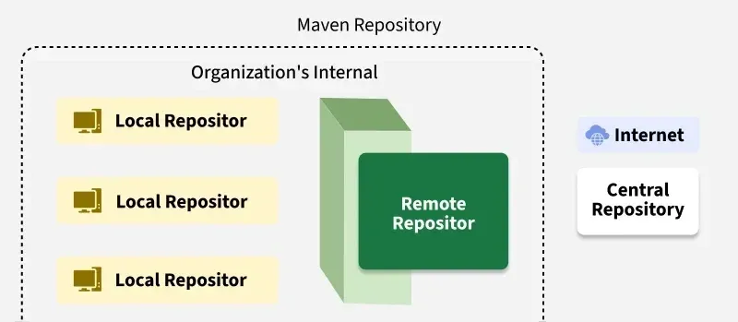

**1. Local Repository**

A local repository is a directory on the developer's machine where Maven stores all the artifacts resolved from remote repositories or created by the developer. And By default, this repository is located at:

C:\Users\{your-username}\.m2\repository

When a dependency is needed, Maven first checks this local repository. If dependency is found, it is used; Otherwise, Maven fetches it from the remote repositories and caches it locally.

**Example:**

1. Create a new Maven project using your preferred IDE (e.g., IntelliJ IDEA, Eclipse) or by running the following command:

mvn archetype:generate -DgroupId=com.geeks -DartifactId=Maven-repo-demo -DarchetypeArtifactId=maven-archetype-quickstart -DinteractiveMode=false

2. add a simple dependency to your pom.xml file to download JUnit for testing.

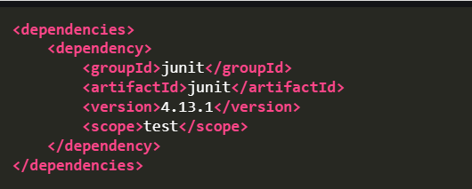

3. Save with ctrl+s or run the following command to compile the project and download the dependency:

mvn clean install

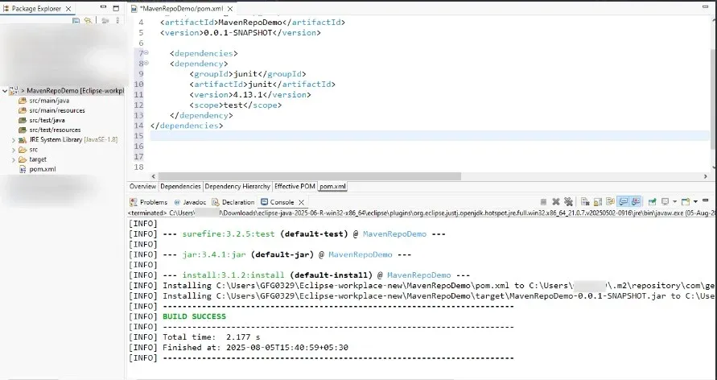

4. Verify the Local Repository:

After running the above command, Maven will download the JUnit dependency from **Maven Central Repository** (since it doesn't exist in your local repository yet) and store it in your local repository. Check at - ~/.m2/repository

**2. Central Repository**

The central repository is a repository provided by the Maven community and maintained by the Apache Software Foundation. It contains a large number of commonly used libraries and is the default repository used by Maven When It needs to resolve dependencies.

https://repo.maven.apache.org/maven2/

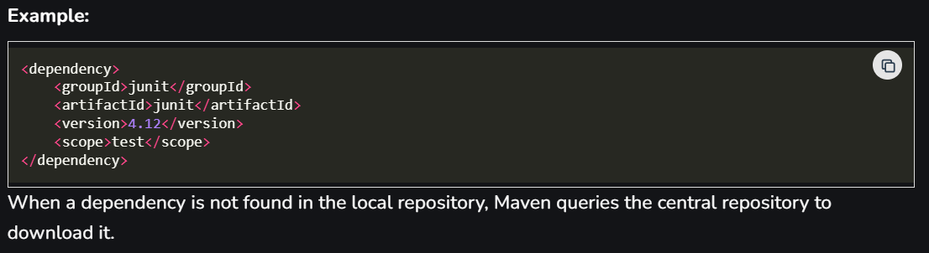

**3. Remote Repository**

Remote repositories are repositories other then the central repository that can be set up by third parties or any organizations to host their own artifact. They are specified in the project's **pom.xml** file in the Maven Settings.

**Example:**

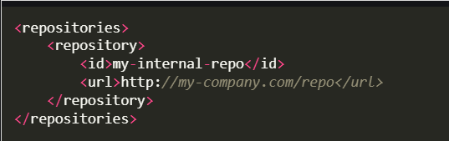

If an artifact is not available in the local repository, Then Maven will check these remote repositories for the required dependencies.

Maven repositories are an essential part of managing dependencies in Maven-based projects. With Maven, you can efficiently manage dependencies, resolve versioning conflicts, and integrate external libraries, greatly simplifying the build process.

===================================================================================

* 1. **Maven Local Repository:**

[Maven](https://www.geeksforgeeks.org/devops/apache-maven/) is a build automation tool used primarily for Java projects. One of its core features is dependency management, facilitated by repositories. A Maven repository is a directory where all the project jars, libraries, plugins, and other artifacts are stored and can be retrieved by Maven to be used in a project.

When we create a Maven project, we need Maven dependencies to complete the software application. Maven Dependency Management first checks the local repository for dependencies. If unavailable, Maven Dependency Management downloads the required dependencies from the central repositories.

**Default Location**

A local repository is a directory on the developer's machine where Maven stores all the artifacts resolved from remote repositories or created by the developer. By default, this repository is located at:

Windows: C:\Users\{your-username}\.m2\repository  
Unix-based systems: ~/.m2/repository

**On Windows:**

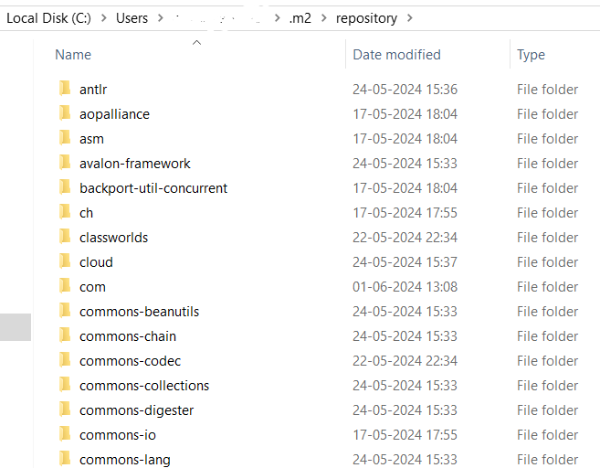

**How the Maven Local Repository Works**

When we run a Maven build command, Maven first checks if the required dependencies are available in the local repository. If not, Maven will check remote repositories. If the required dependencies are found, Maven downloads them and stores them in the local repository. Then Maven uses those dependencies from the local repository.

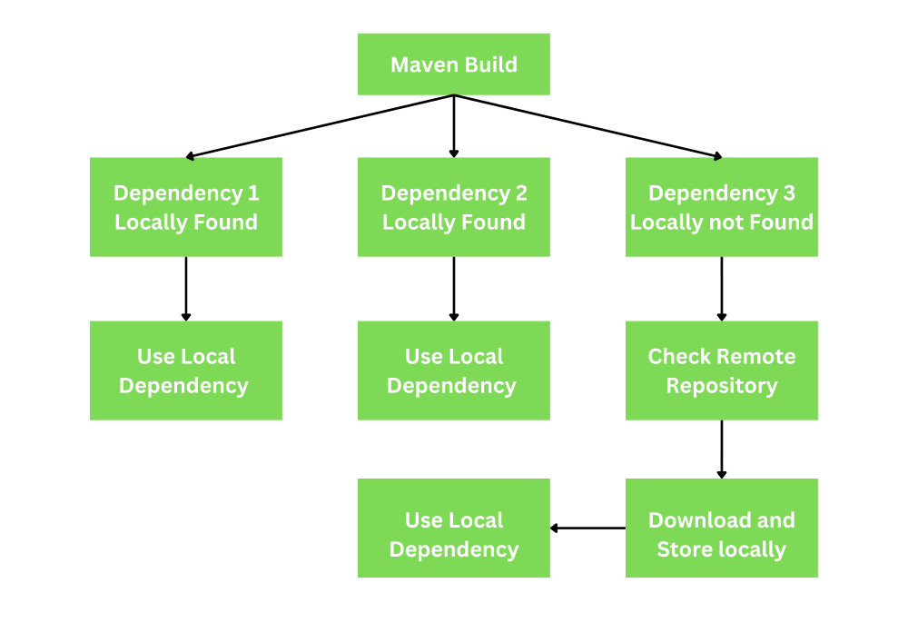

**Explanation:**

Below we provide step by step how maven local repository works for better understanding.

* Maven Build: The Maven Build process is started when you run maven build command like mvn clean and mvn install.
* Check Local Repository: After this Maven first checks local repository for required dependencies in this location ~/.m2/repository.
* Dependencies Found Locally: If required dependencies are available in the local repository then maven will use them.
* Dependency Not Found Locally: If required dependencies are not available in the local repository then Maven checks remote repositories.
* Download from Remote: If the dependency is available in a remote repository, Maven downloads it and stores it in the local repository.
* Use Downloaded Dependency: Once downloaded, Maven uses the dependency from the local repository for the build process.

This workflow ensures that Maven projects can be built efficiently by reusing previously downloaded dependencies and only downloading missing ones when necessary.

**Applications of Maven Local Repository**

The Maven provide lot application for make development easy.

* Dependency Management: Simplifies dependency management by automatically handling downloads and updates.
* Offline Builds: Allows for offline builds using previously downloaded dependencies.
* Custom Repositories
  + Supports custom local repositories for internal libraries and artifacts.
  + Enables the use of proprietary or internal artifacts that are not available in public repositories.
* Build Performance: Speeds up builds by reusing previously downloaded dependencies and Reduces the need to download dependencies multiple times.
* Version Control: Facilitates easy rollback to previous versions if needed.

**==================================================================================**

* 1. **Maven Central Repository:**

The **Maven Central Repository**is a widely used repository for Java developers to find open-source libraries and artifacts in Maven projects. It is the default repository in Apache Maven, a build automation tool primarily used for Java projects. Later, it was updated to support other types of projects like C# and Ruby.

**Purpose of Maven Central Repository**

* It provides a central location to host and share Java libraries and Artifacts.
* This facilitates easy management of project dependencies and it allowing developers to automatically download necessary libraries.
* It can manage different versions of libraries and compatibility
* Collaboration by sharing and using common libraries within the community.

**Workflow of Maven Central Repository**

* **Define Dependencies:** Developers specify the required dependencies in their Maven projects **pom.xml**file.
* **Search and Download:** Maven searches for the specified dependencies in the local repository first, if not found It looks up in the Maven Central Repository.
* **Fetch Artifacts:** If dependencies are available in the central repository they are downloaded to the local repository for future use.
* **Build Project:** Maven uses dependencies to build the project.

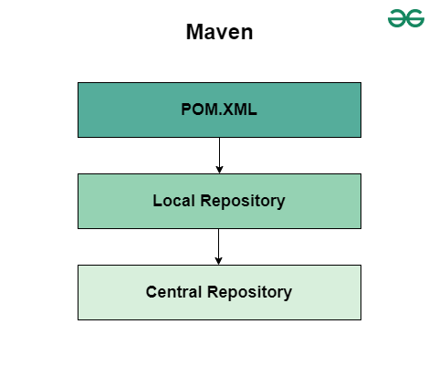

**Maven Dependency Resolution Progress**

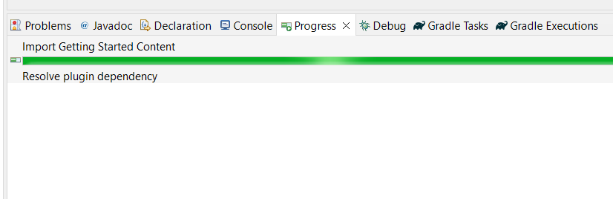

We can observe the above image. In the above image, there is a green color progress bar. This bar indicates the **downloading the required project dependencies from the central maven repository**. Once everything is completed then it is ready for development. And it can provide build phases also for project build.

**Detailed Workflow with Steps:**

* **Project Initialization:**Developers creates a Maven Project and defines dependencies in **pom.xml**file.
* **Build Invocation:**Developers runs **mvn install**or **mvn package**.
* **Dependency Check:**Maven checks the local repository for the specified dependencies. If dependencies are not found locally, Then Maven queries the Maven Central Repository.
* **Artifact Retrieval:**The Maven Downloads the required dependencies from the central repository. And The dependencies are stored in the local repository for future use.
* **Project Compilation:**Maven complies the project using the resolved dependencies.
* **Build and Packaging:**Maven packages the project into the desired output format like JAR or WAR and other formats.

**Applications:**

* Dependency Resolution
* Build Automation
* Quality Assurance
* Open-Source Distribution

===================================================================================

* 1. **Maven Remote Repository:**

**Maven Remote Repository**is one of the repositories in the Maven repositories. It is a repository on a remote server that contains artifacts, that can be used by[Maven](https://www.geeksforgeeks.org/devops/apache-maven/) projects. These artifacts include libraries, plugins, and other dependencies that a project may require. The remote repository is accessed over a network on the internet and allows Maven to fetch dependencies that are not available in the local repositories.

**Types of Remote Repositories:**

* **Central Repository:**The Default repository provided by Maven and Hosted at Maven Central contains a wide range of commonly used libraries and dependencies.
* **Corporate Repository**: A repository hosted within an organization typically used to manage and share internal artifacts securely among various systems.
* **Third-Party Repository**: A repository managed by a third-party organization hosting libraries and dependencies that may not be available in the central repository.
* **Snapshot Repository**: A repository designed to host snapshot versions of artifacts which are interim builds that may change frequently before a final release.
* **Release Repository**: A repository dedicated to hosting stable and final versions of artifacts, ensuring that dependencies are reliable and do not change unexpectedly.

**Purpose of Maven Remote Repository:**

* **Dependency Management:**It allows project to download dependencies that are not available locally.
* **Centralized Storage:**Provides a centralized place where all maven artifacts can be stored and accessed by any developers or project.
* **Version Control:**Manages different versions of artifacts ensuring that the correct versions are used and conflicts are avoided.
* **Collaboration:**Facilitates sharing and collaboration among developers and teams by providing a common repository for storing and retrieving dependencies.

**Example of Maven Remote Repository:**

A common example of a Maven Remote Repository is the Maven Central Repository which is a large repository of libraries and component maintained by the Apache Software Foundation.

**<repository>**

**<id>central</id>**

**<url>https://repo.maven.apache.org/maven2</url>**

**</repository>**

**Applications Workflow with Maven Remote Repository:**

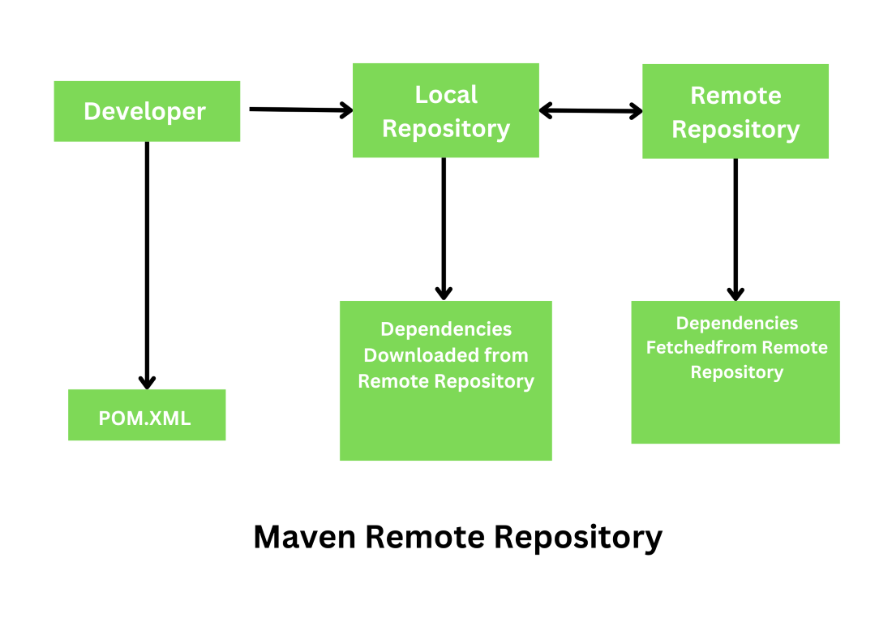

* Project Setup: The Developers defines the project structure and creates the pom.xml file. Specifying required dependencies and plugins.
* Build Command: The Developers runs a Maven Build command like mvn clean install
* Local Repository Check: The Maven checks the local repository for the required dependencies.
* Remote Repository Check: If the dependencies are not found locally, Then maven connects to the remote repository to download the required artifacts.
* Dependency Download: The dependencies are downloaded from the remote repository and stored in the local repository.
* Build Process: Maven uses the downloaded dependencies to build the project.
* Deploy Artifacts: If configured the build artifacts can be deployed to a remote repository for sharing with other projects.

**Security Considerations When Using Remote Repositories:**

* Authentication and Authorization: Ensure proper authentication mechanisms like username and password or tokens are in place to control access to the repository, and use authorization rules to restrict actions based on user roles.
* Transport Layer Security: Use TLS/SSL to encrypt data transmitted between Maven clients and the repository to protect.
* Repository Access Control: Implement access controls to restrict who can upload or modify artifacts in the repository to prevent unauthorized changes.
* Artifact Verification: Verify the integrity and authenticity of artifacts by using checksum and digital signatures
* Dependency Management: Regularly update dependencies to their latest versions to mitigate vulnerabilities, and avoid using deprecated or unmaintained repositories.
* Audit Logs: Maintain detailed logs of repository access and artifact changes to monitor for suspicious activities and perform security audits.
* Automated Scanning: Use automated tools to scan artifacts for known vulnerabilities before integrating into our projects to ensure they do not introduce security risks.
* Isolation of Repositories: Use separate repositories for different environments.
* Backup and Recovery: Implement a robust backup and recovery plan to ensure repository data can restored in case of accidental deletion or data corruption.
* Compliance: Ensure that the repository and its usage comply with relevant security policies, regulations and standards to avoid legal and compliance issues.

**==================================================================================**

* 1. **Apache Maven Artifact:**

An **Apache Maven artifact**is a file, typically a JAR (Java Archive), created when a project is built. Each artifact is uniquely identified by three main coordinates: groupId, artifactId, and version.

Maven artifacts are package units of your software. When building a project, Maven uses these artifacts to manage dependencies, plugins, and libraries. An artifact can be a library, module, framework, or any other package that a project requires. These artifacts are stored in repositories, either local, central, or remote, and are retrieved and used as needed by Maven during the build process.

* **groupId**: This is the unique identifier of the organization or group that created the project.
* **artifactId**: This is the unique name of the project.
* **version**: This indicates the specific version of the artifact.

**==================================================================================**

* 1. **Clearing the Maven Cache:**

The Maven cache, or local repository, is a directory on your computer where Maven stores all downloaded files. These include project dependencies, plugins, and other artifacts required for building projects. Storing these files locally accelerates build times since Maven can reuse previously downloaded dependencies.

**Create a Maven Project**

To create a new Maven project, follow these steps:

1. Open your command prompt or terminal.

2. Run the following command to create a new project:

**mvn archetype:generate -DgroupId=com.example -DartifactId=my-app -DarchetypeArtifactId=maven-archetype-quickstart -DinteractiveMode=false**

This command generates a new Maven project with a basic structure.

**Adding Dependencies**

Dependencies are external libraries required for your project. You can add them to your Maven project by editing the pom.xml file. For example:

1. Open the pom.xml file in your project.

2. Add the following code inside the <dependencies> tag:

**<dependency>**

**<groupId>org.springframework.boot</groupId>**

**<artifactId>spring-boot-starter-web</artifactId>**

**<version>2.5.4</version>**

**</dependency>**

This code adds the Spring Boot web starter dependency to your project.

**Configuring Plugins**

Plugins add extra functionality to Maven. You can configure plugins in the pom.xml file. Here’s an example of adding the Maven compiler plugin:

1. Open the **pom.xml** file.

2. Add the following code inside the **<build>** tag:

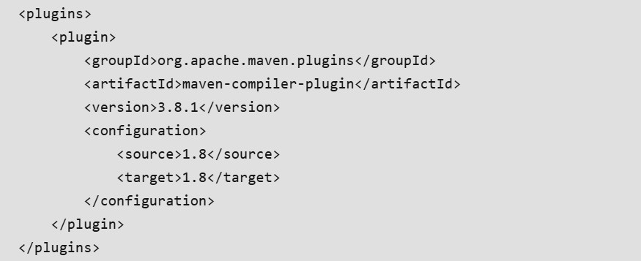

**Clearing the Maven Cache**

To clear the Maven cache, you can simply delete the local repository folder. Here’s how you can do it:

1. Locate the Maven cache folder, usually found at **~/.m2/repository** on Unix-based systems or

* On Unix-based systems: ~/.m2/repository
* On Windows: C:\Users\YourUsername\.m2\repository

2. Delete the contents of the repository folder.

Alternatively, you can use the following Maven command to clear specific artifacts from the cache:

**mvn dependency:purge-local-repository**

This command removes all the dependencies from the local repository.

******************************************************************************************************************************************************************************************************************************************************************************************

**Section 10: Maven Profiles**

* 1. **Configuring Spring Boot Applications with Maven Profiles:**

In a software development environment, applications must often be configured differently for various environments such as development, testing, and production. Managing these configurations can be challenging, but [Maven](https://www.geeksforgeeks.org/devops/apache-maven/) provides powerful features called profiles to handle this.

* **Maven profiles** allow you to customize the build configurations for different environments by specifying different settings in the **pom.xml** file.
* This ensures that the application runs smoothly in each environment with the correct settings.

**Maven Profiles**

Maven profiles are sets of configurations that can be activated or deactivated based on certain conditions. They allow you to define different configurations for various environments such as development, testing, and production. Each profile can have its own dependencies, plugin properties, and build settings.

**Working of Maven Profiles**

Maven profiles can be defined in the pom.xml file. We can activate a profile using command line parameters, environment variables, or other activation mechanisms. When a profile is activated, Maven uses the settings defined in that profile to build the project.

**Key Points:**

* **Maven**: Maven is a build automation tool primarily used for Java projects. It provides a comprehensive project management framework that allows you to manage dependencies, build processes, and project structure efficiently.
* **Profile**: A profile in Maven is a set of configuration settings that allows you to customize the build for different environments. Profiles can be activated via the command line, through the settings.xml, or based on system properties.
* **Dependency**: A dependency in Maven is a Java library or project that the project relies on to build and run. Dependencies are declared in the pom.xml file and are automatically downloaded from Maven repositories.
* **Plugin**: A plugin in Maven is an extension to the build lifecycle, providing additional goals and functionality. The Spring Boot Maven Plugin, for example, simplifies the process of building and running Spring Boot applications.
* **Dependency Management**: It is the process of handling and maintaining all the dependencies required for the project. Maven automates this process by downloading the required libraries and managing versions.

******************************************************************************************************************************************************************************************************************************************************************************************